**Screen Shots**

1. Local Worker:
   1. Efficiency:

* 1 thread-10 ms:

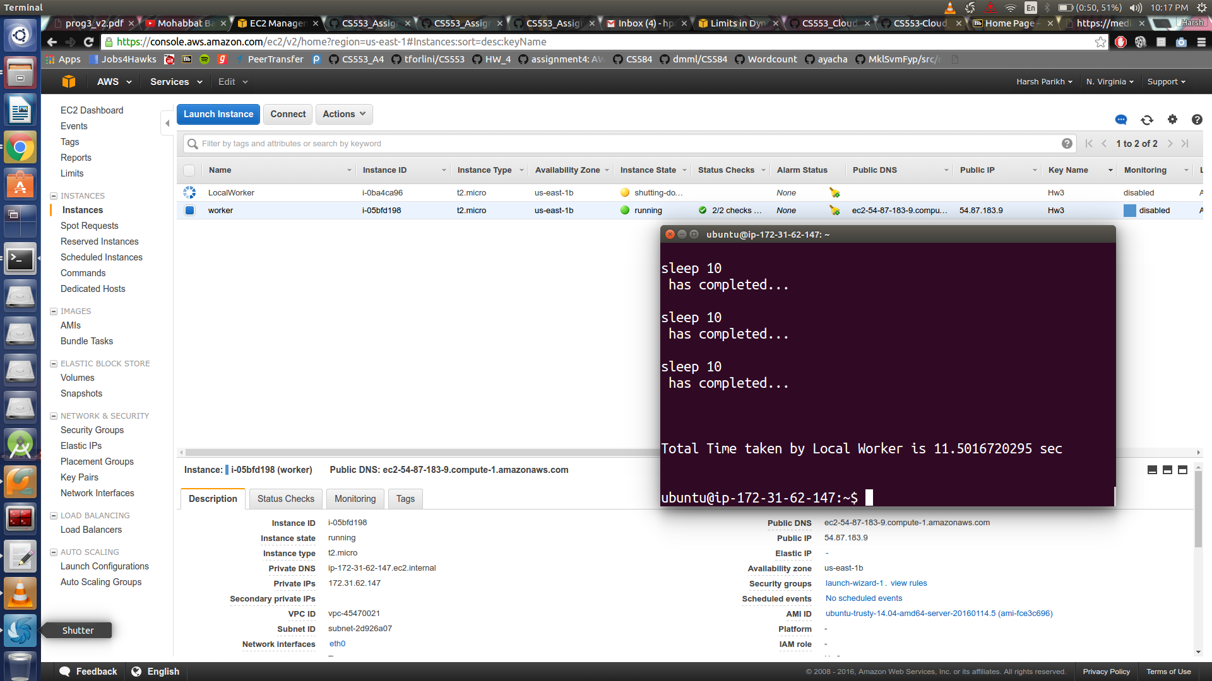

* 1 thread-1 Sec:

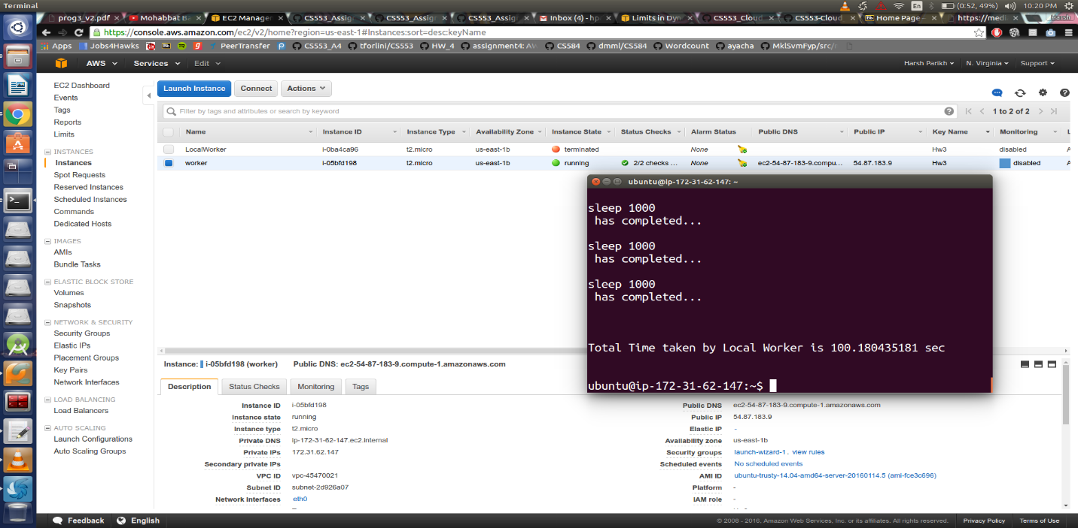

* 1 thread-10 Sec:

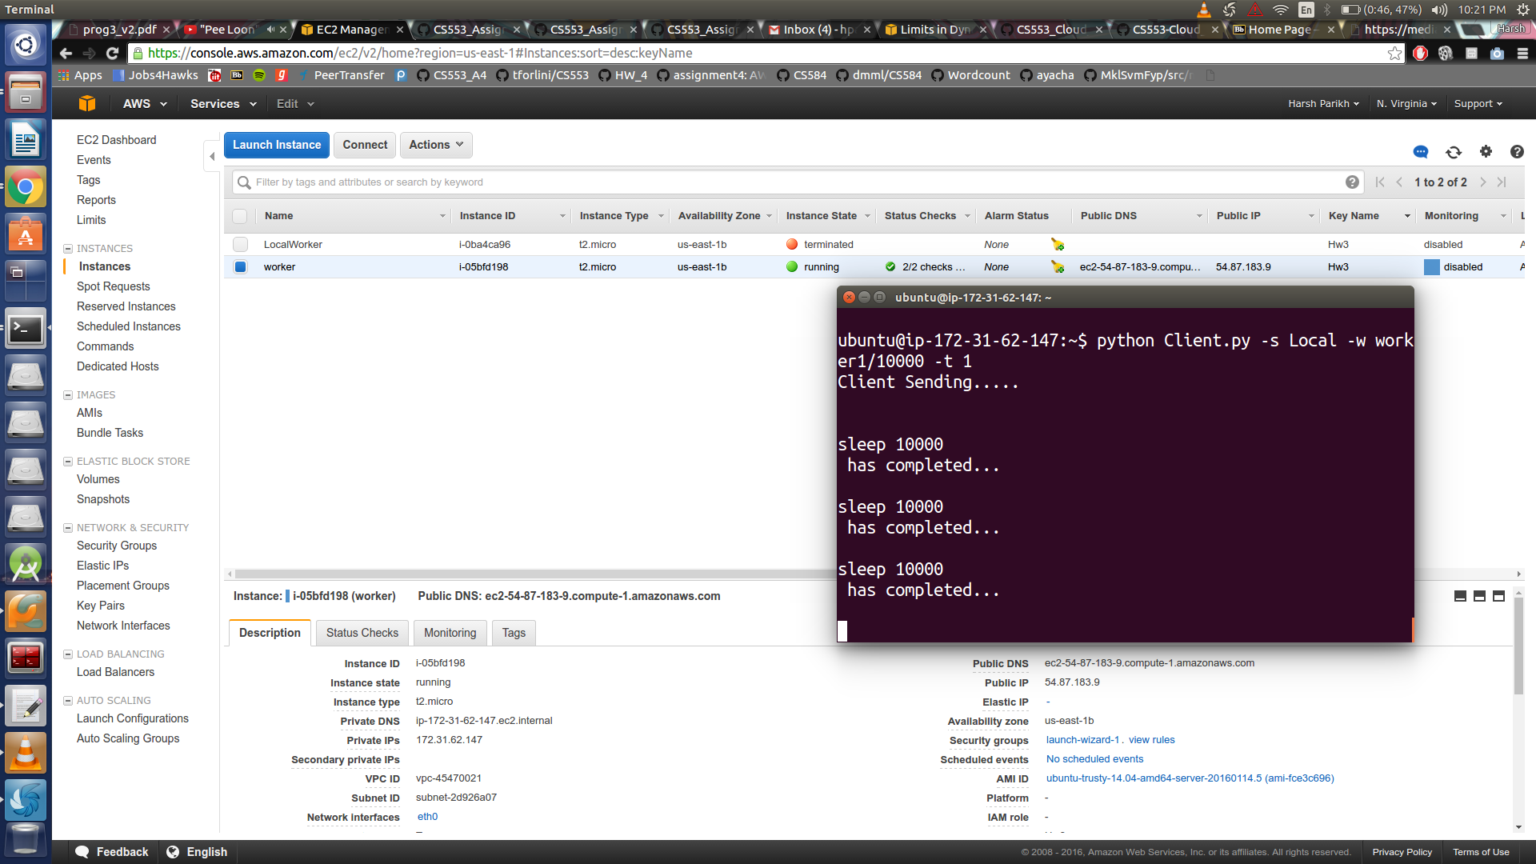

* 2 thread-10 ms:

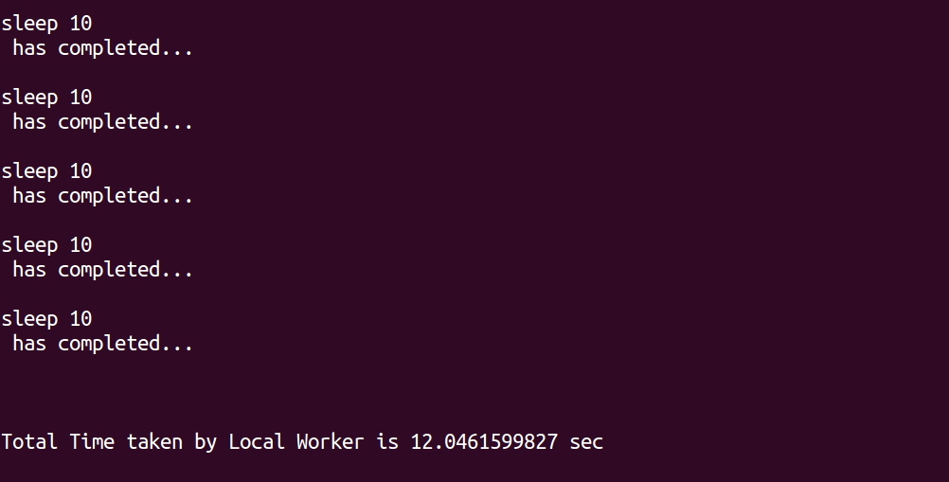

* 2 thread-1 Sec:

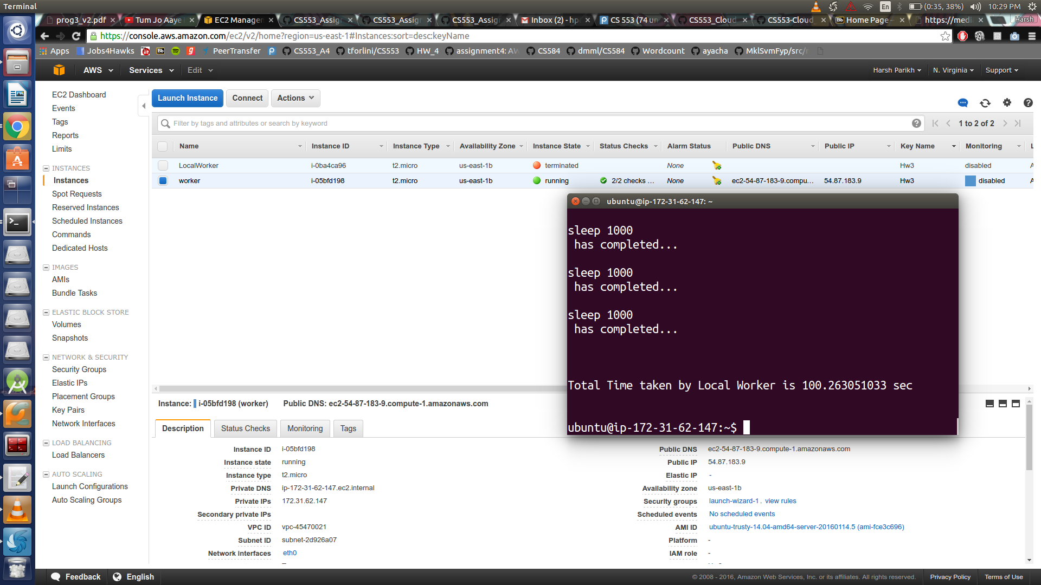

* 2 thread-10 Sec:

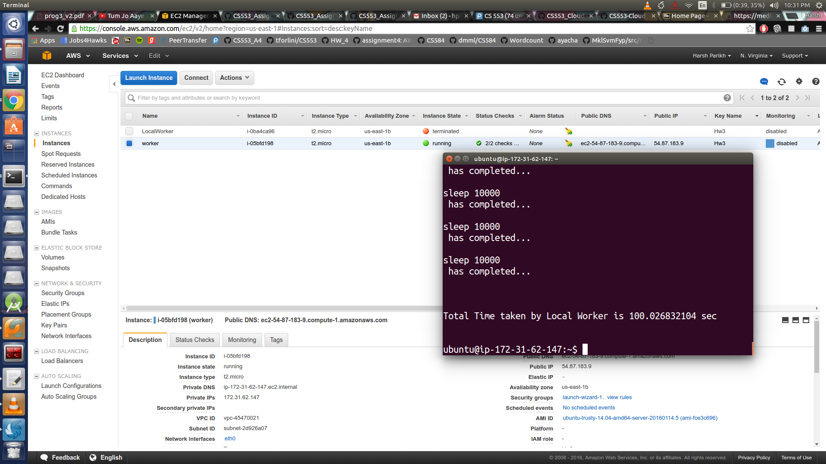

* 4 thread-10 ms:

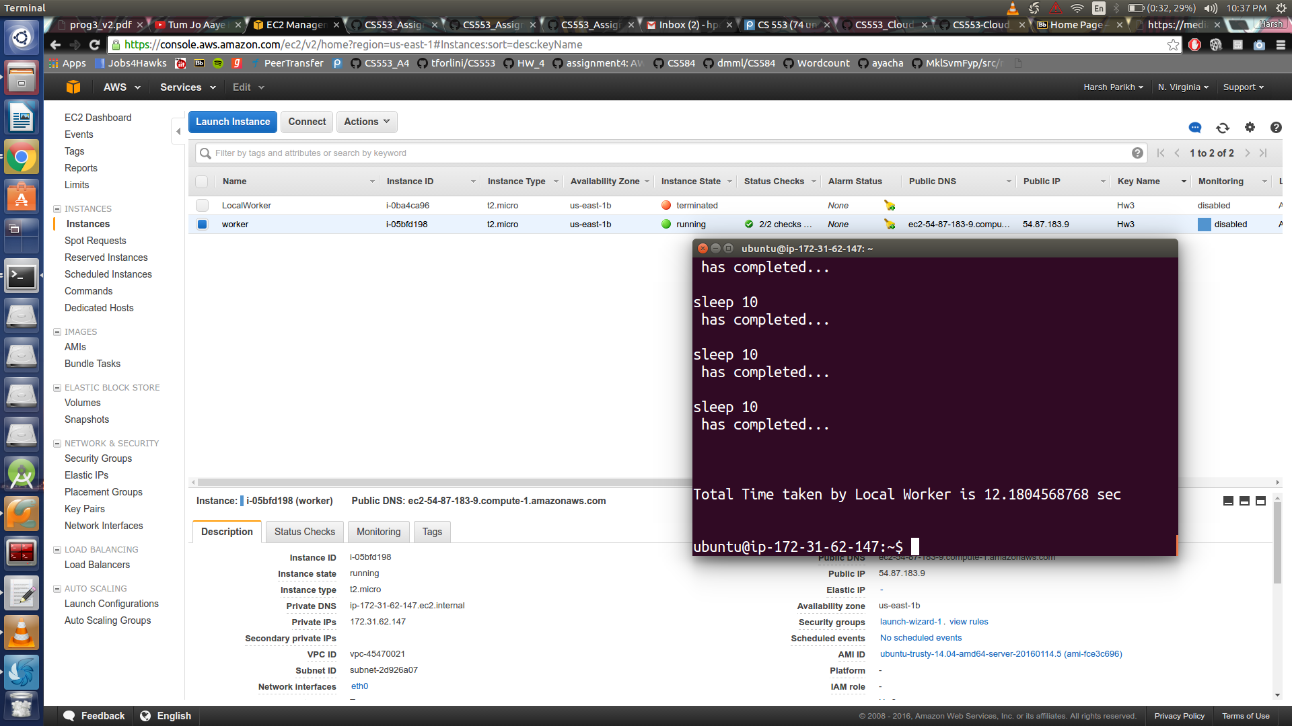

* 4 thread-1 Sec:

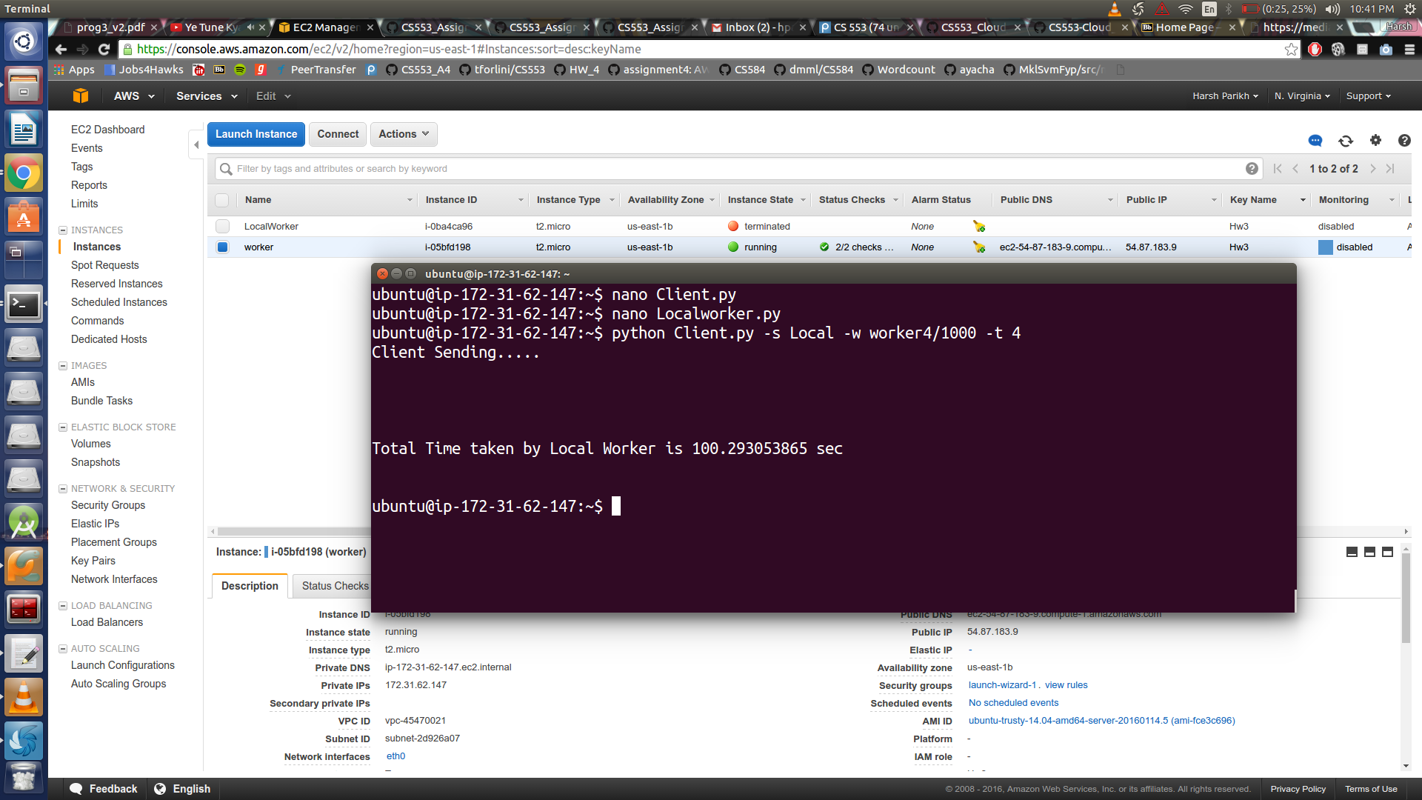

* 4 thread-10 Sec:

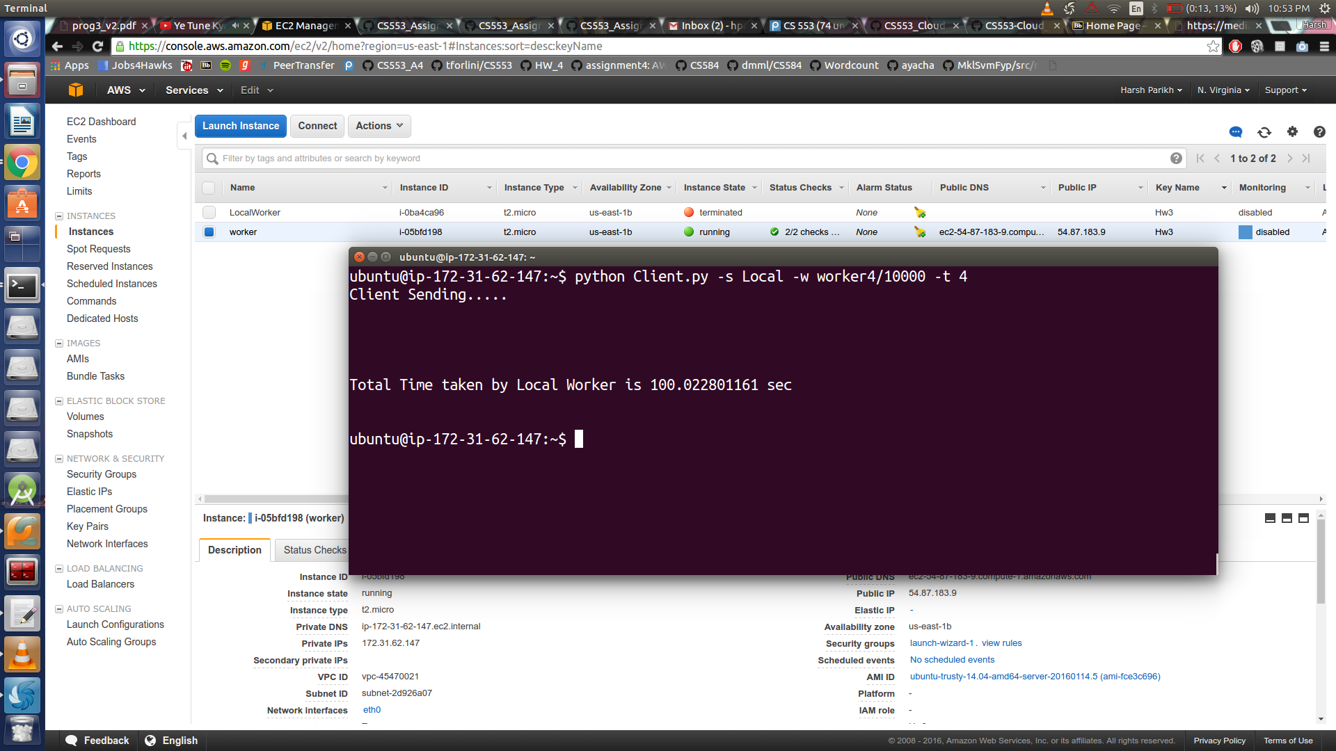

* 8 thread-10 ms:

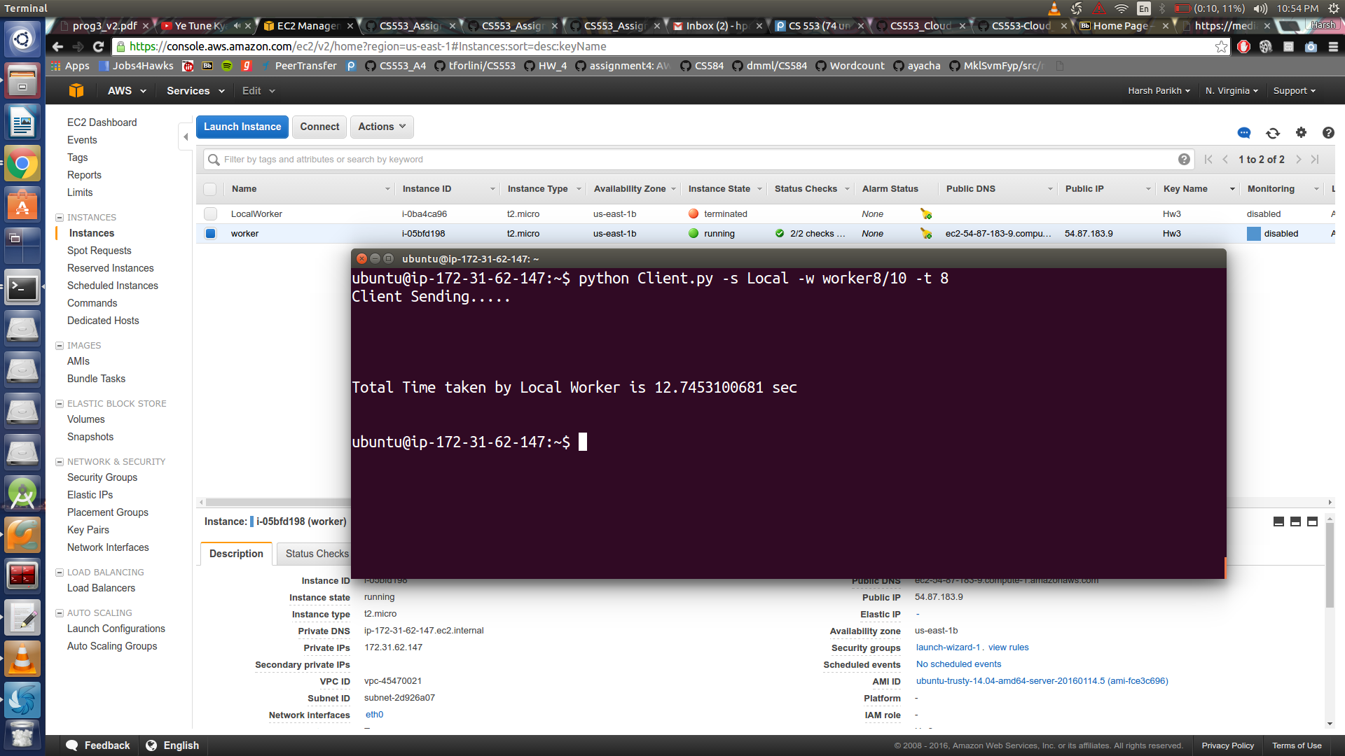

* 8 thread-1 Sec:

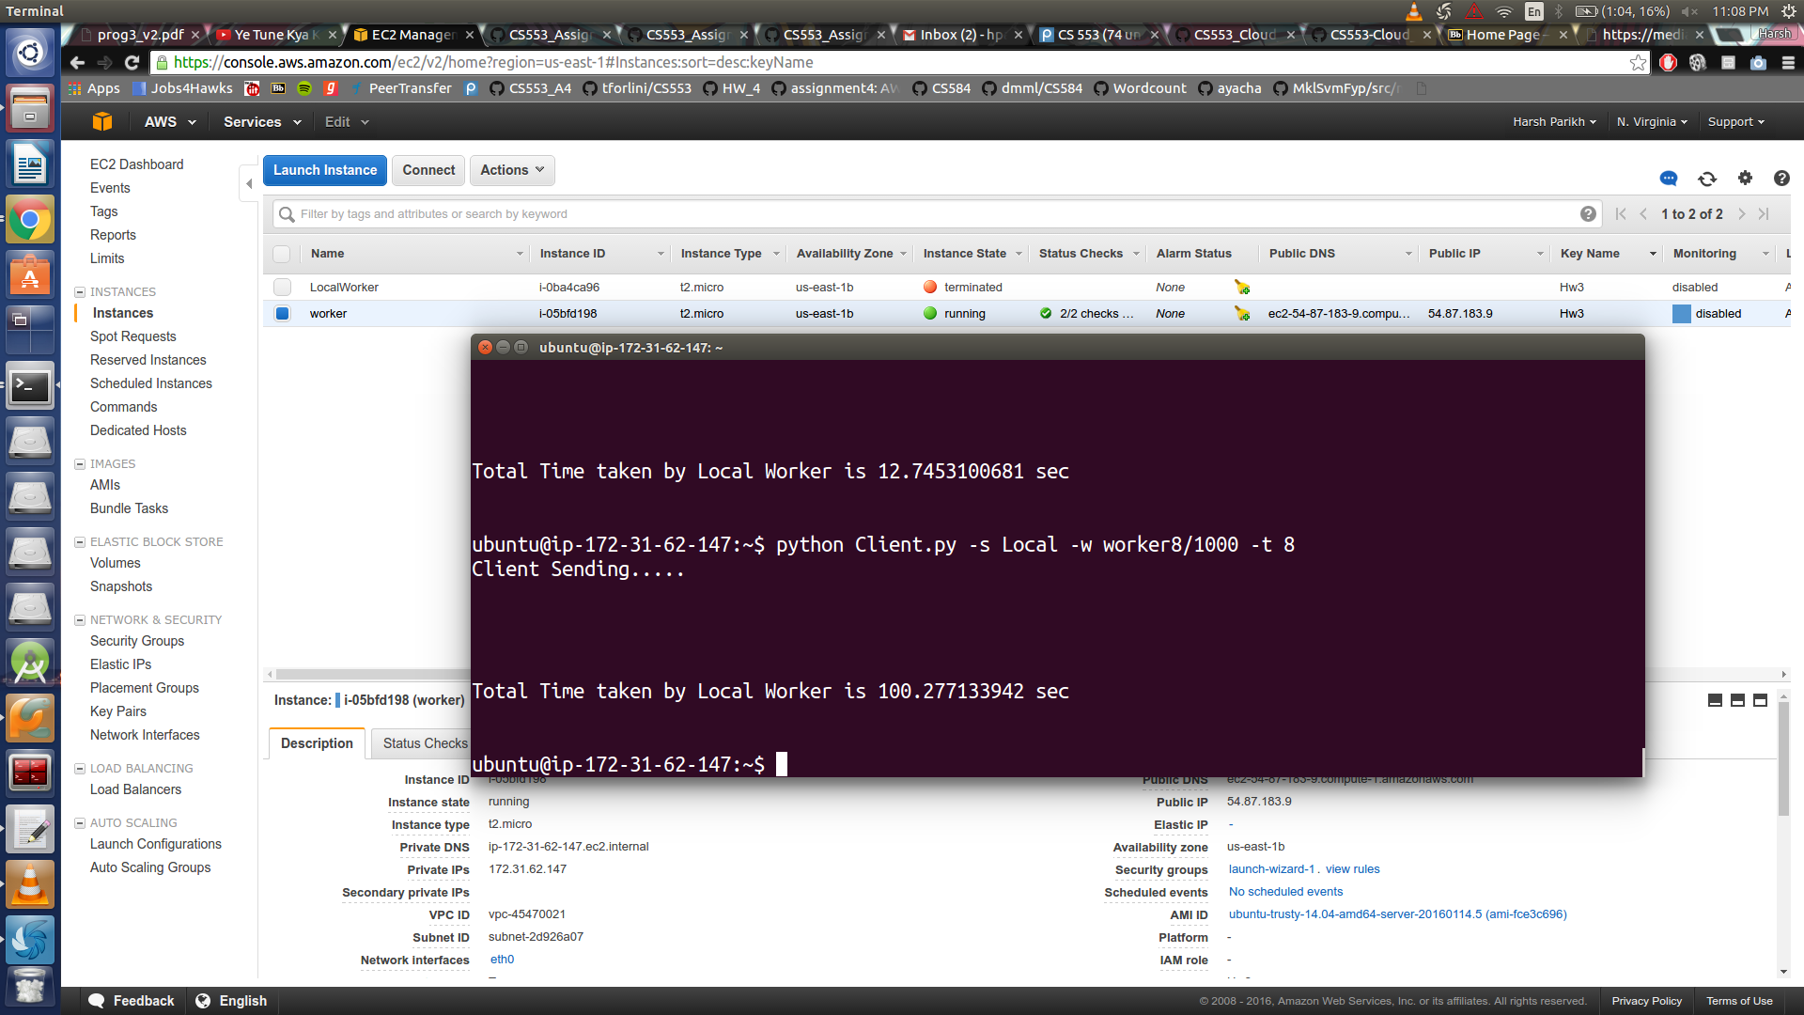

* 8 thread-10 Sec:

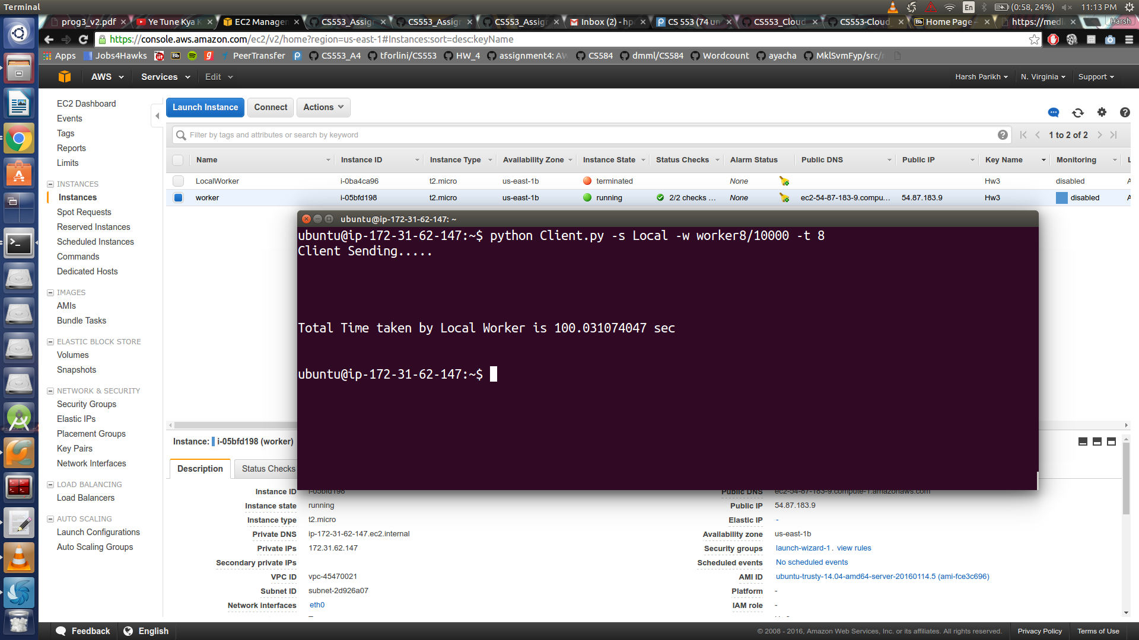

* 16 thread-10 ms:

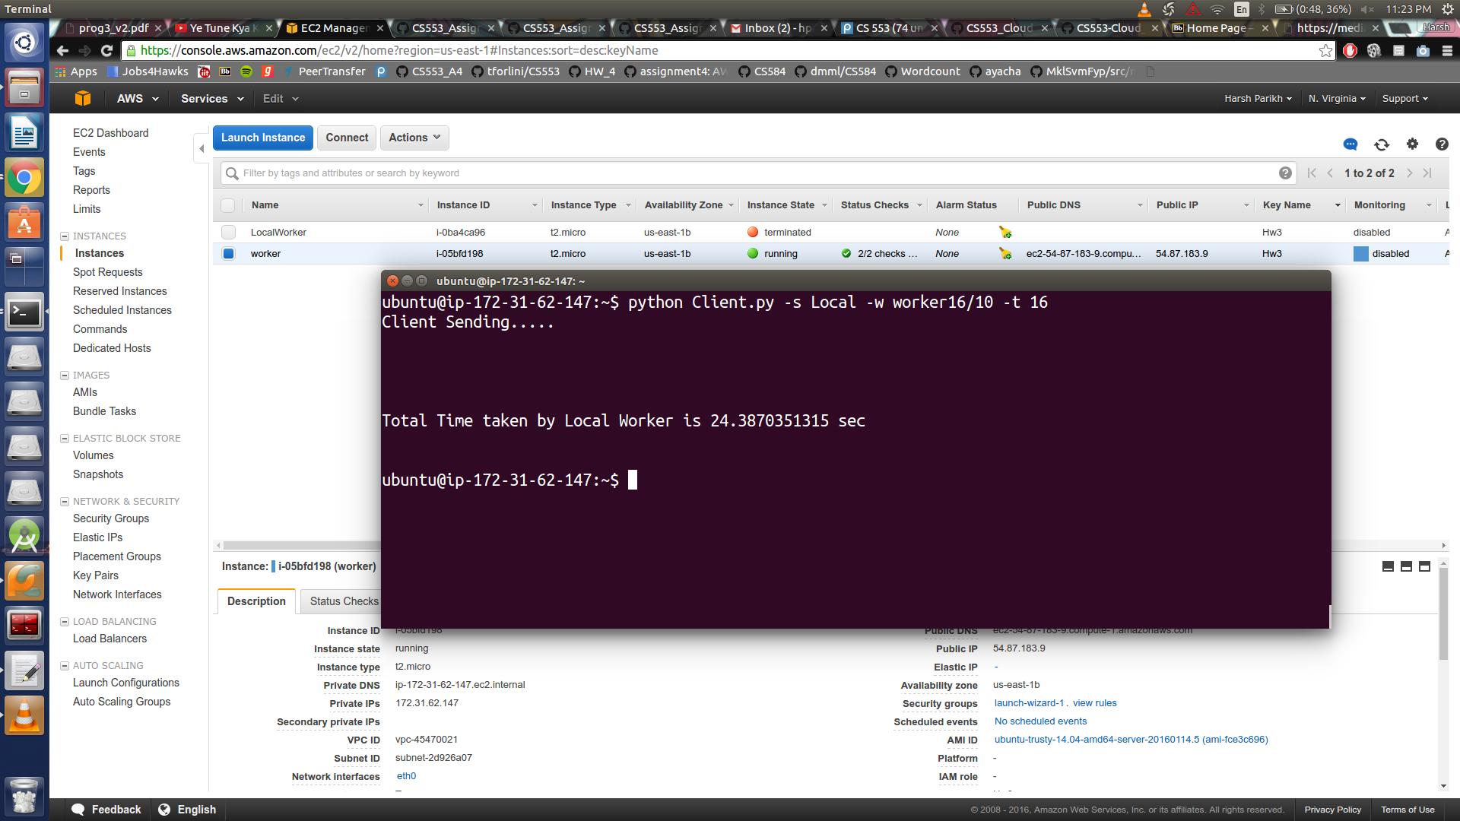

* 16 thread-1 Sec:

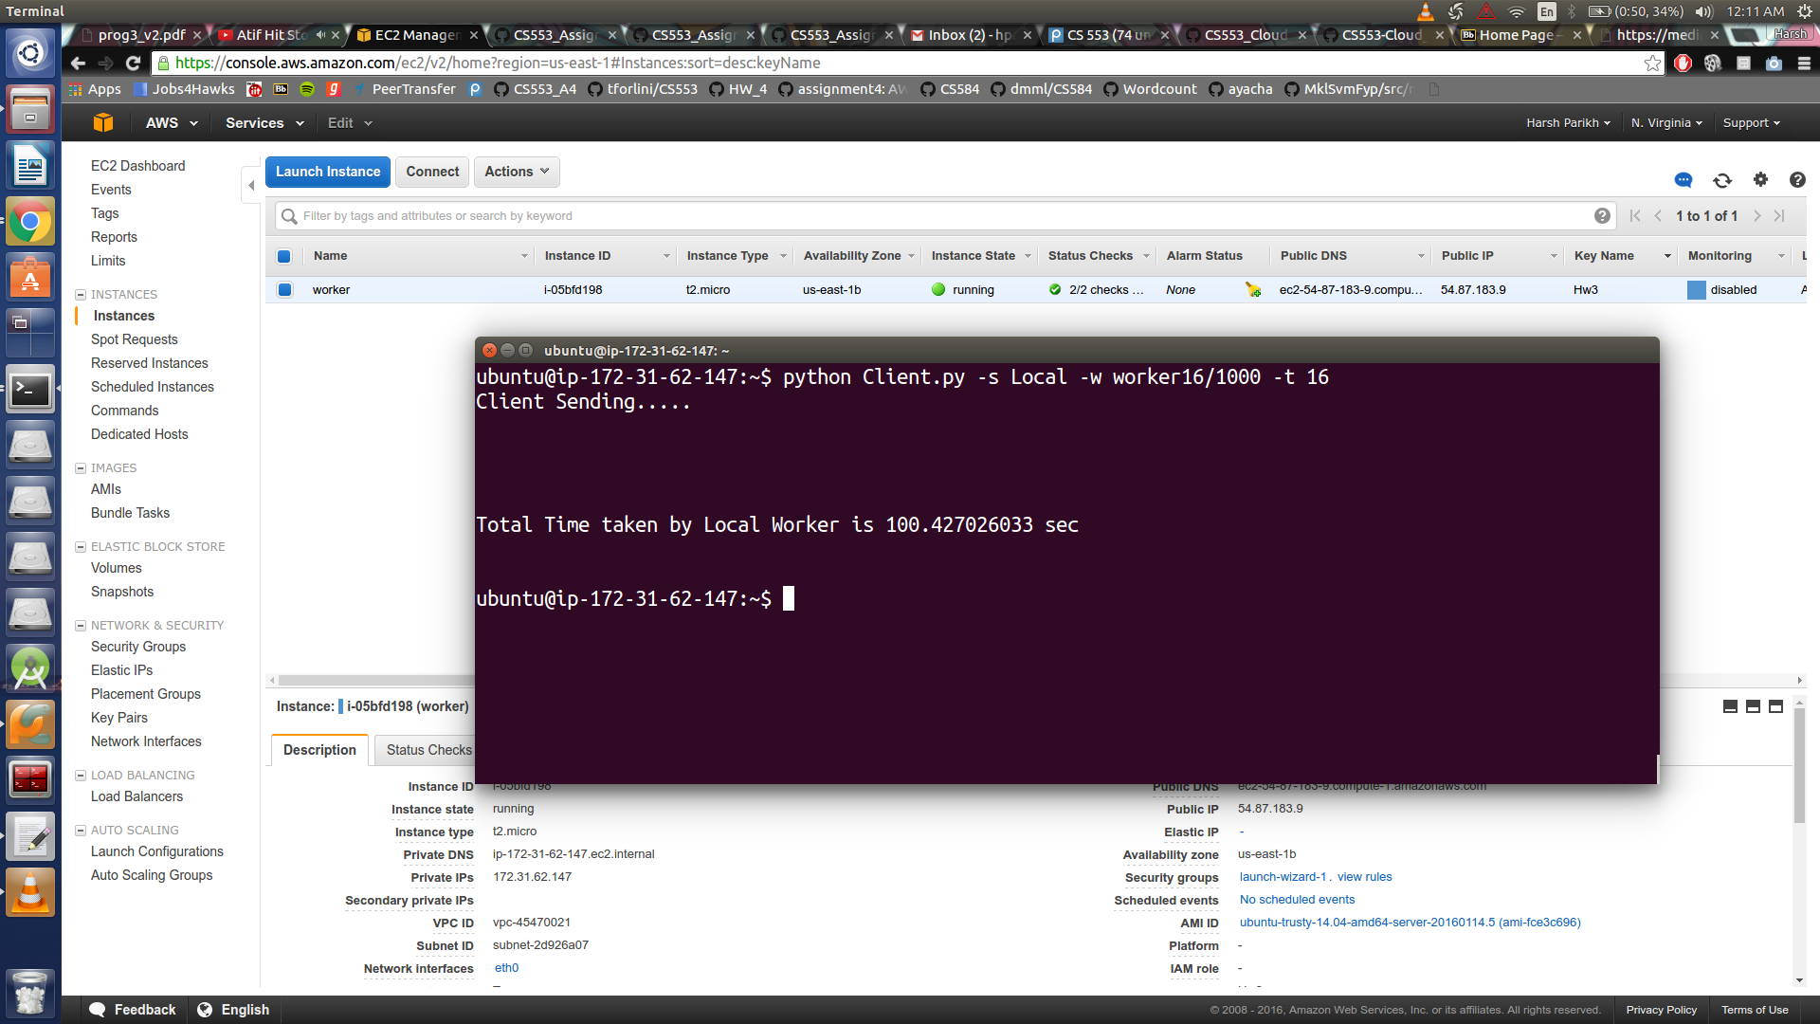

* 16 thread-10 Sec:

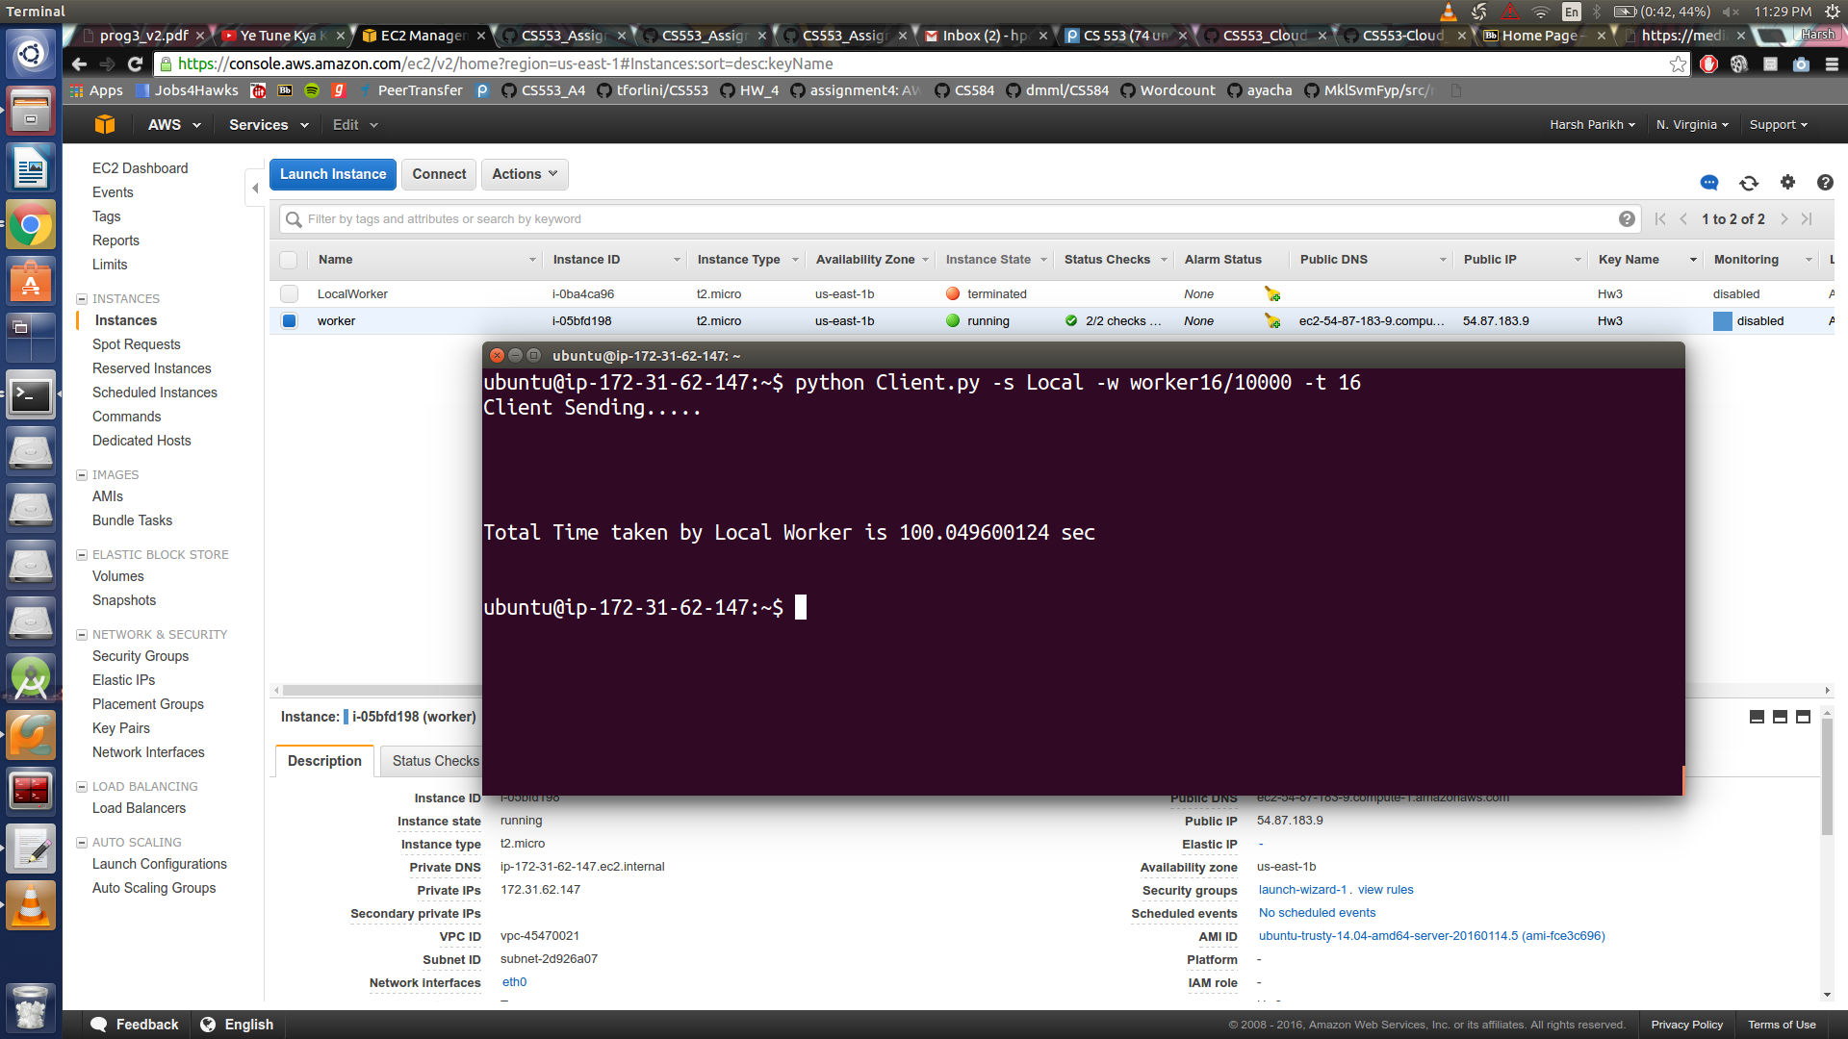

* **Local Worker Script**

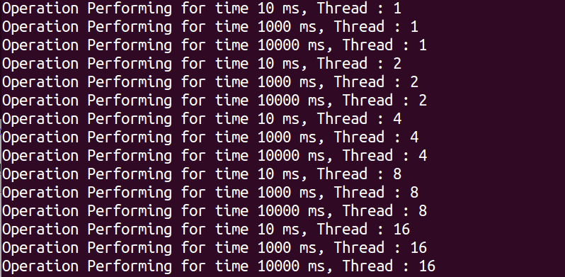

1. Throughput:

* 1 Thread (Sleep-0):

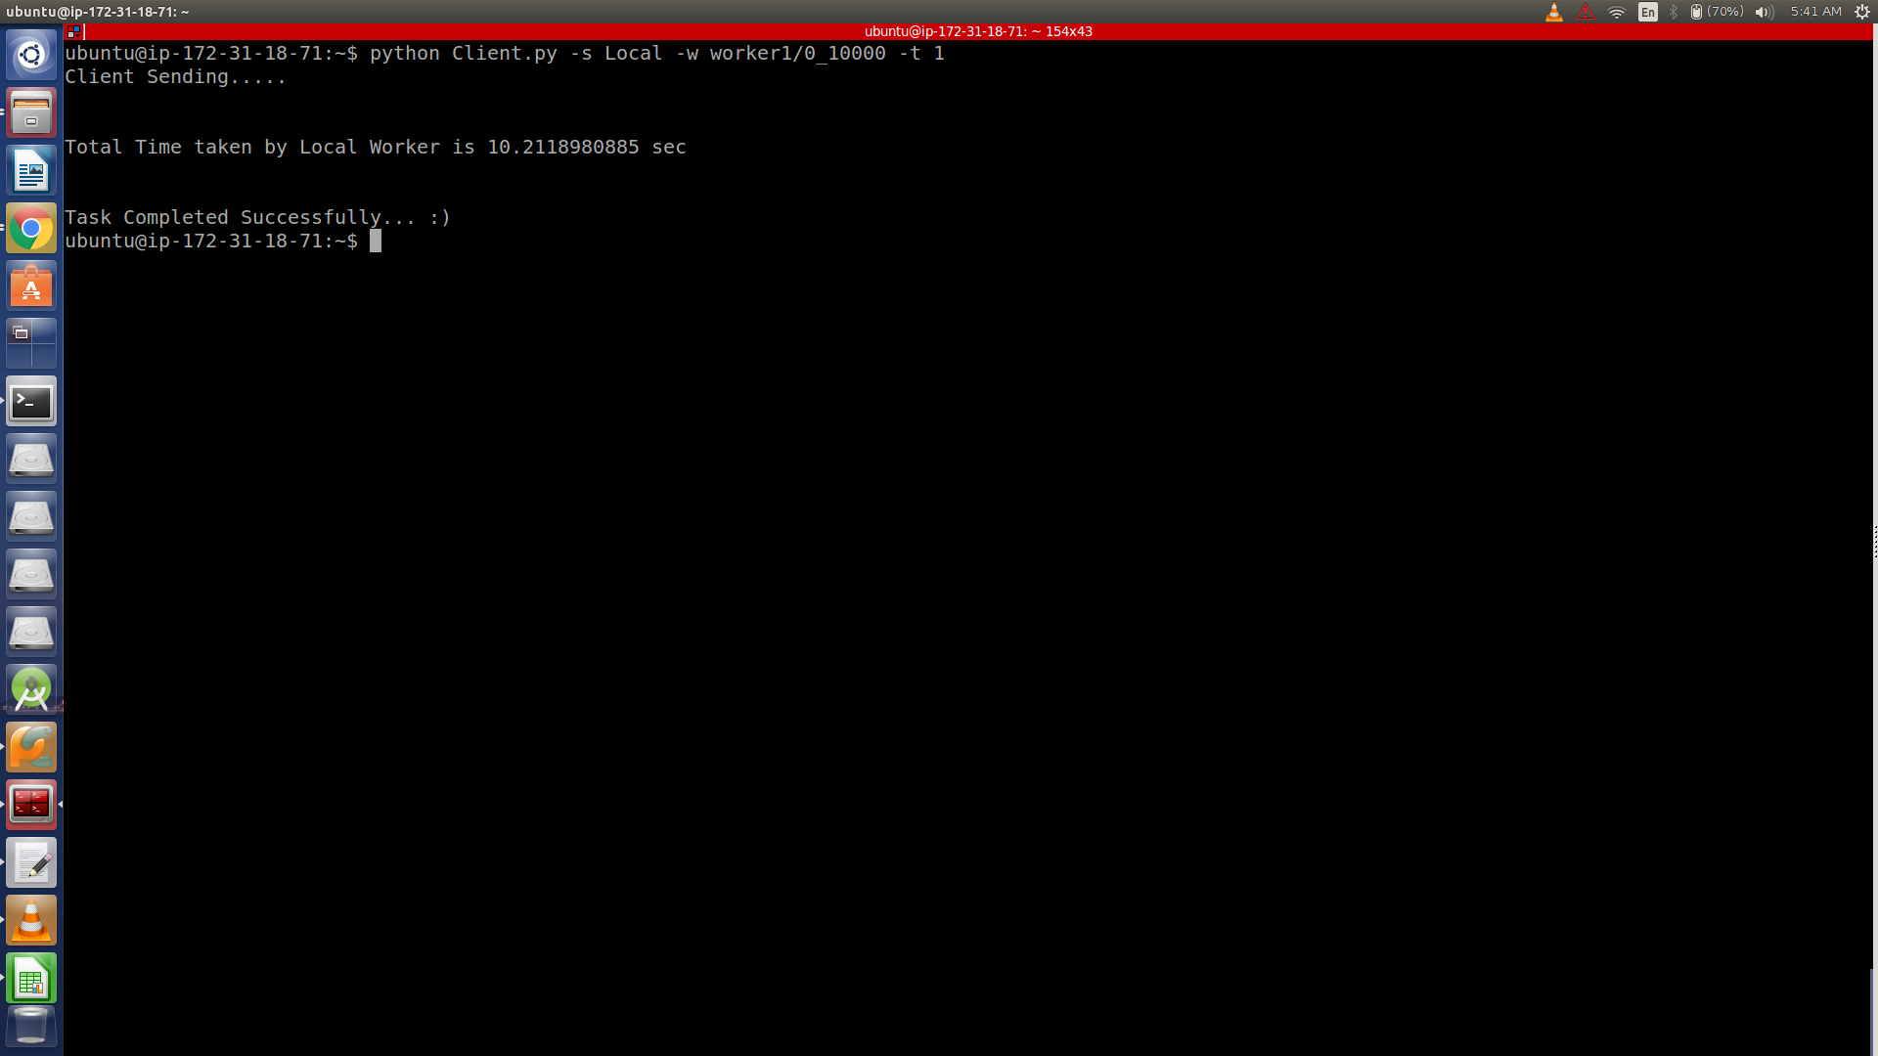

* 2 Thread (Sleep-0):

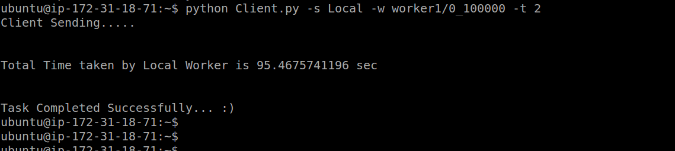

* 4 Thread (Sleep-0):

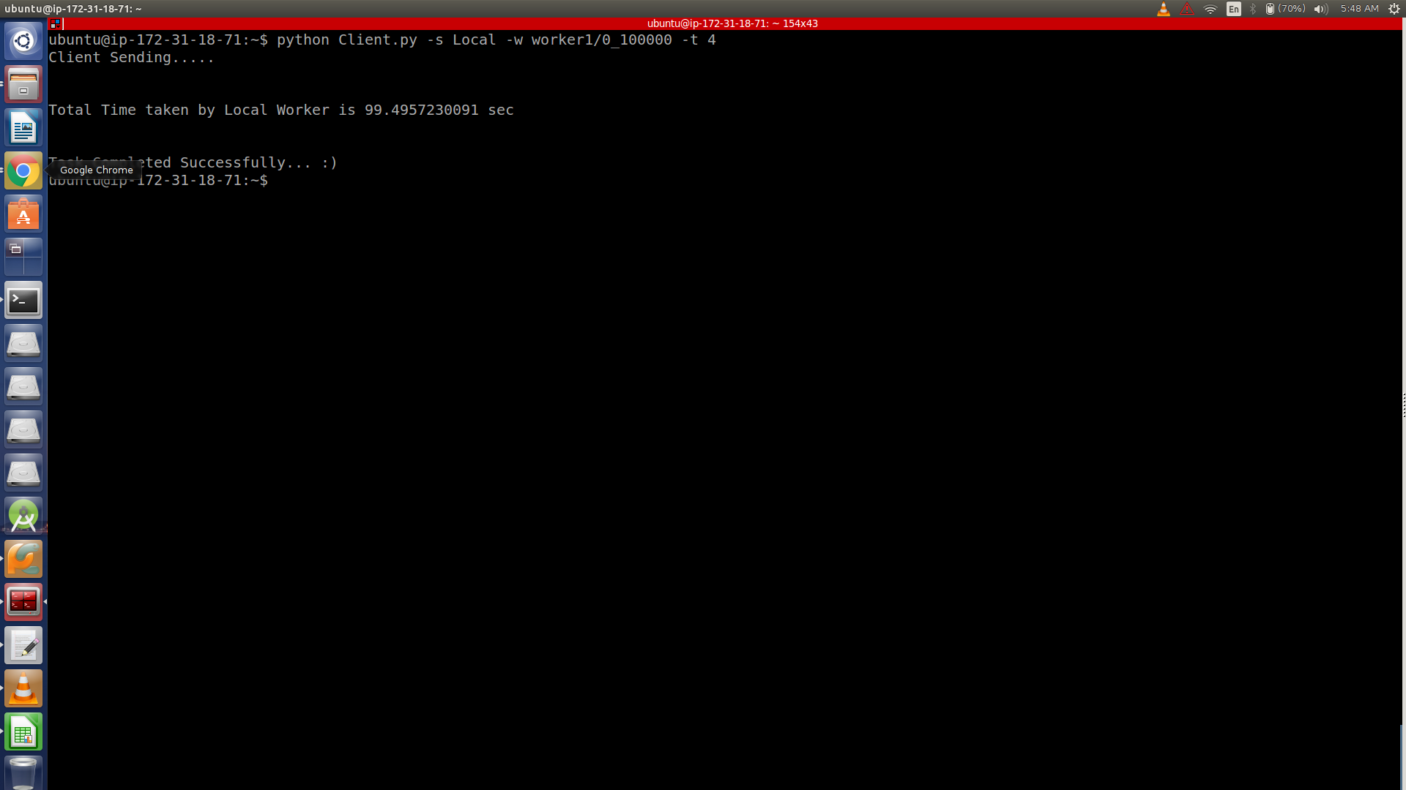

* 8 Thread (Sleep-0):

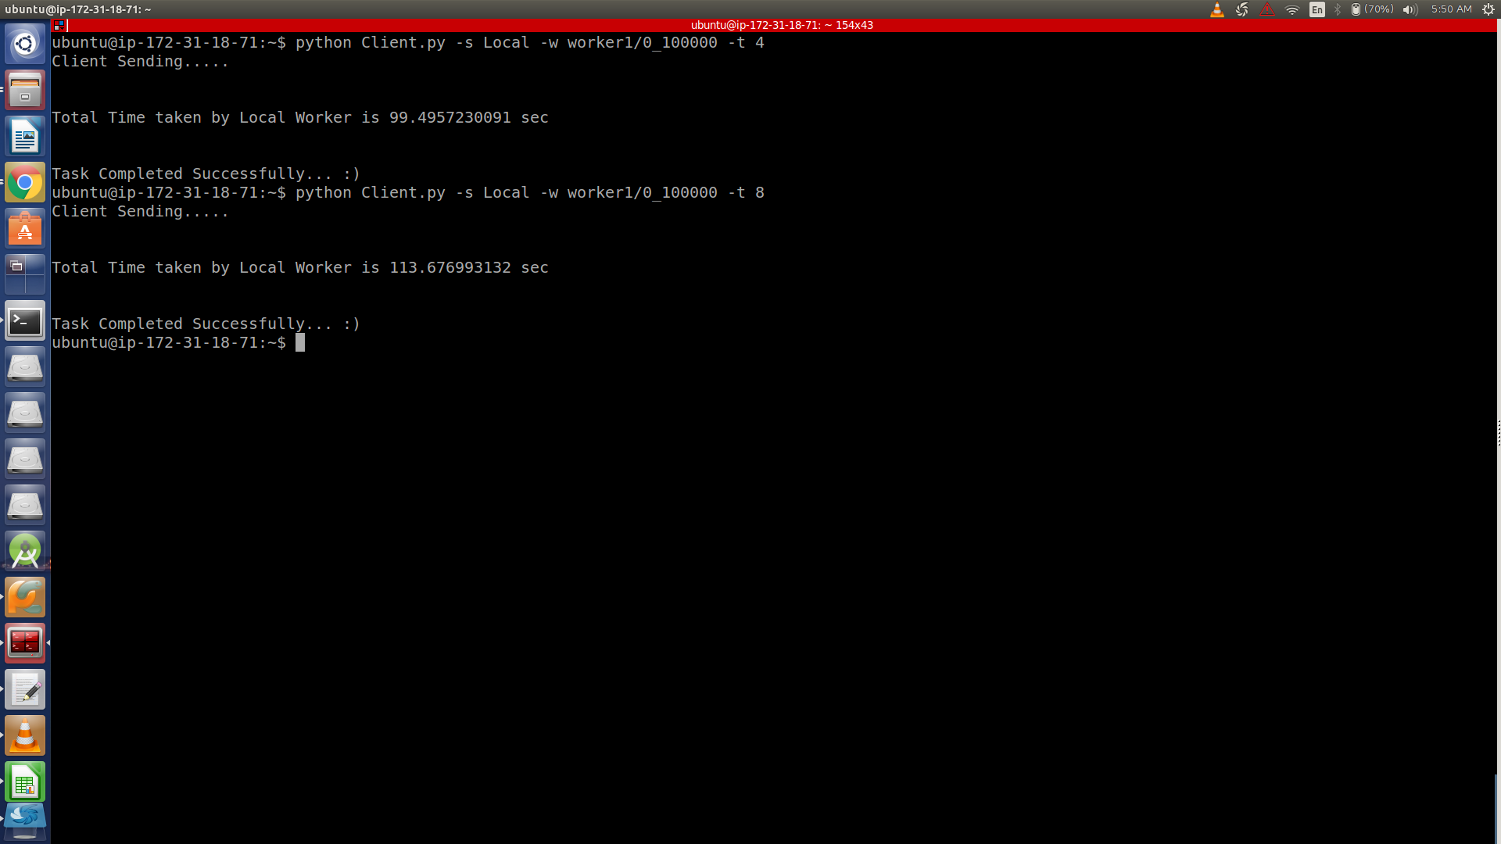

* 16 Thread (Sleep-0):

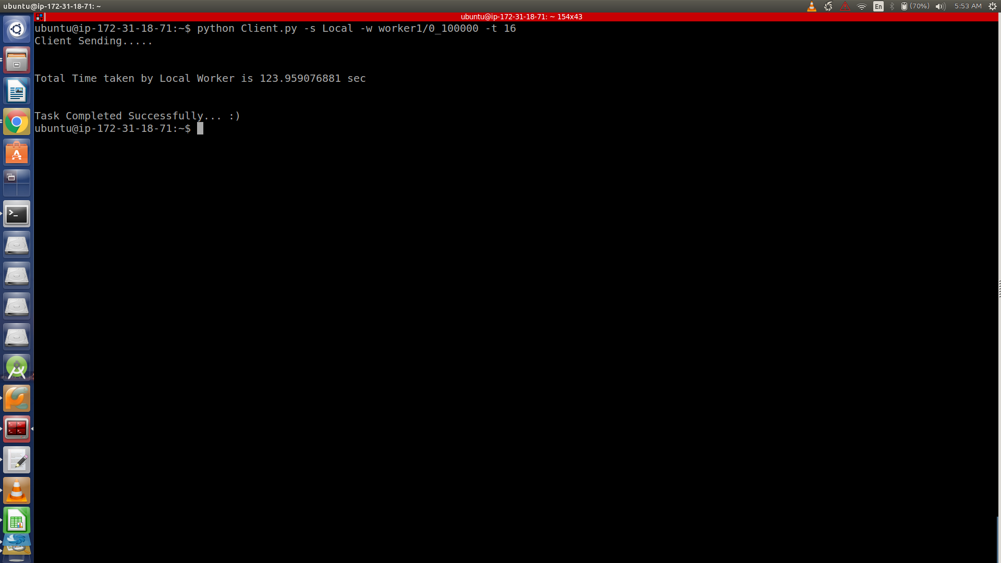

1. Amazon SQS:
   1. Amazon SQS (Request Queue – Response Queue):

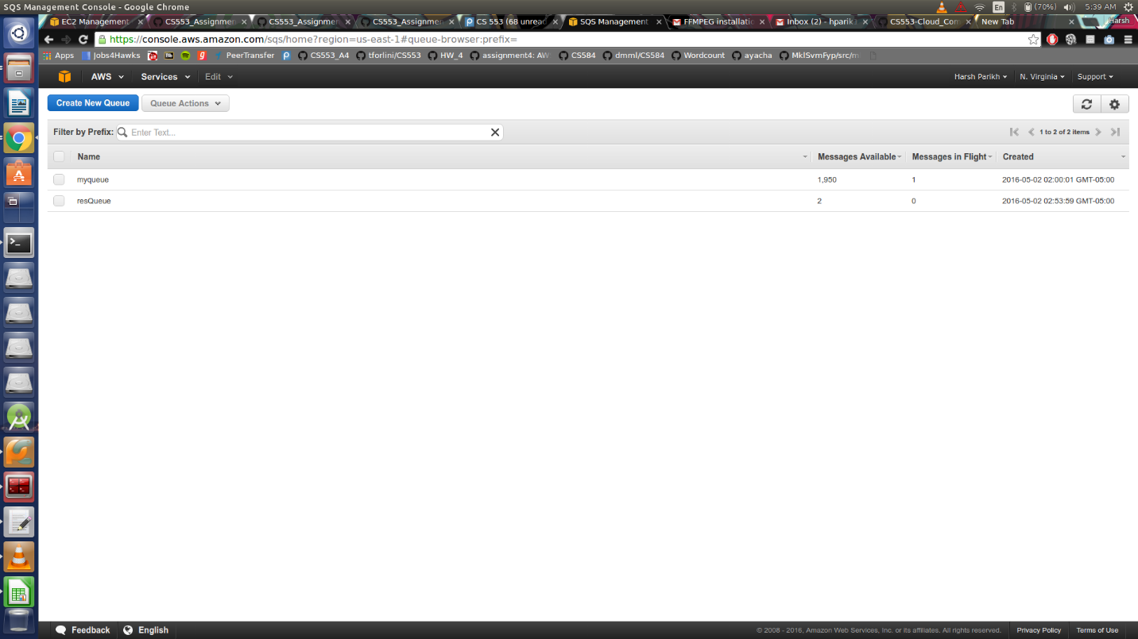

* 1. DynamoDB:

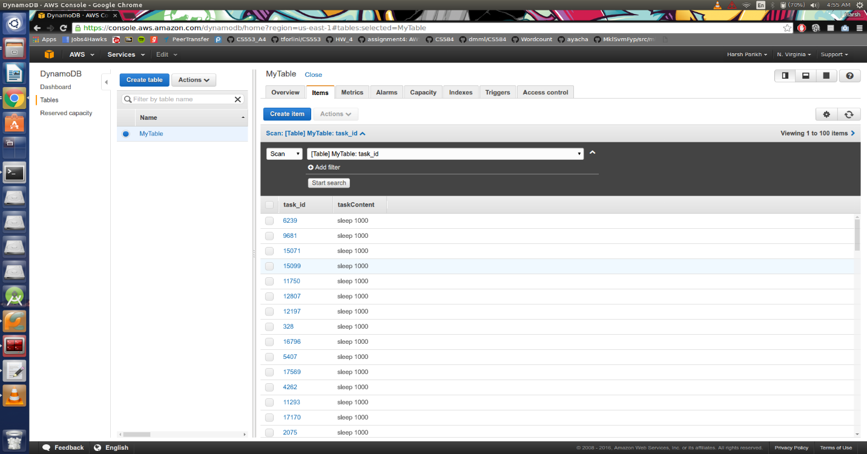

* 1. Efficiency:
* 1 thread-10 ms:

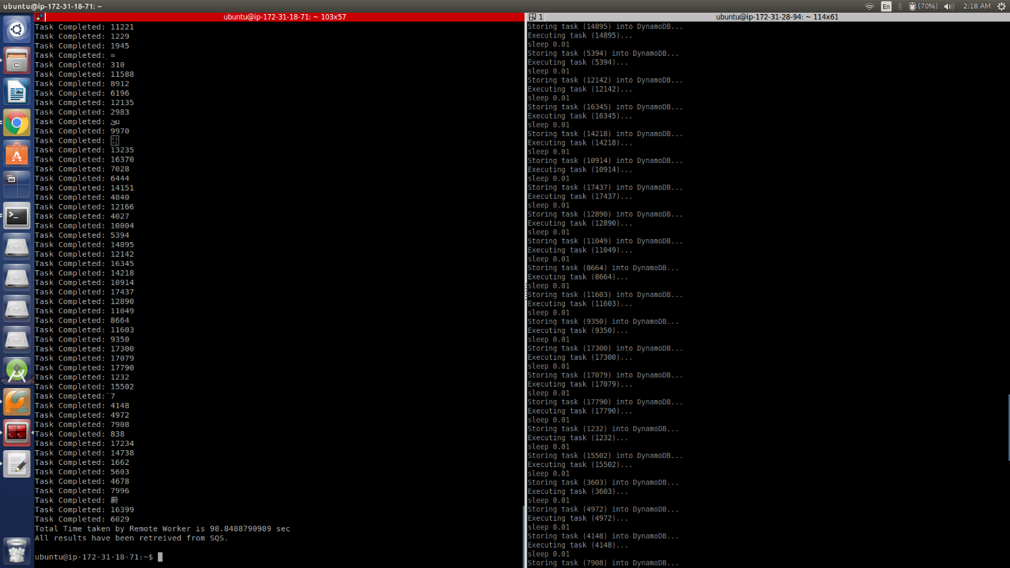

* 1 thread-1 sec:

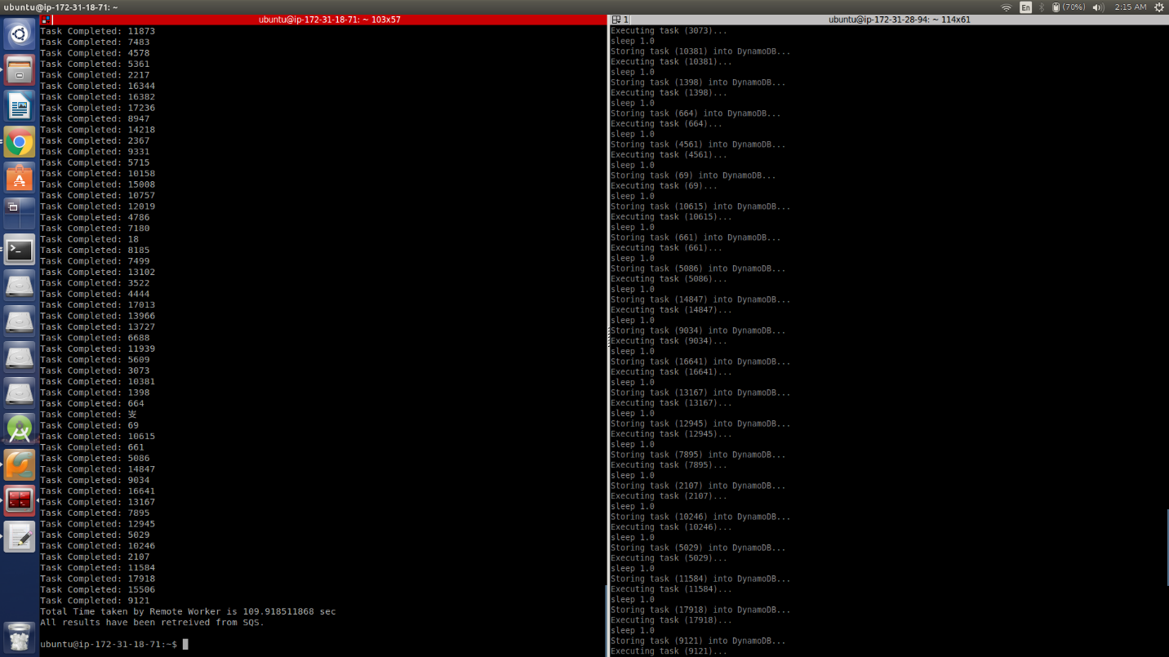

* 1 thread-10 sec:

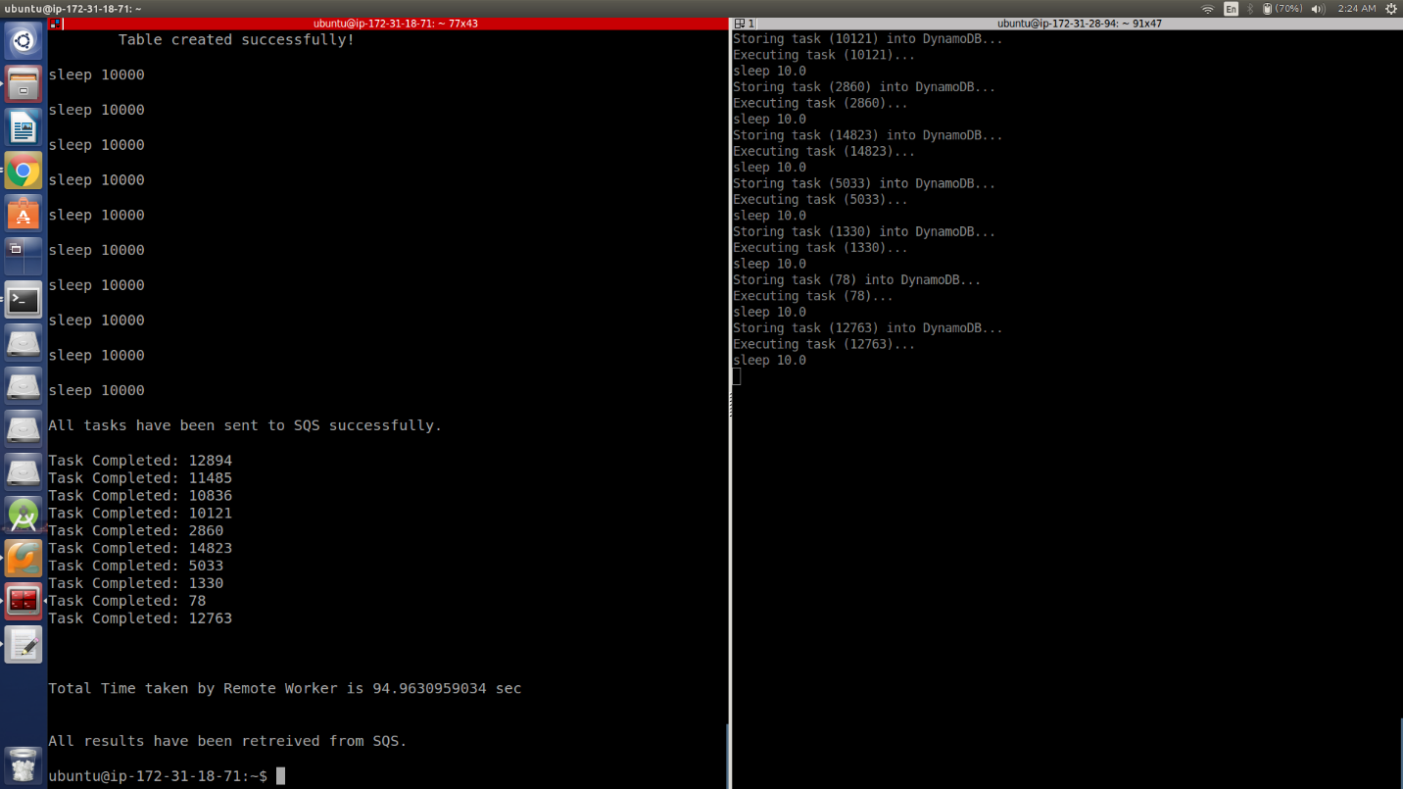

* 2 thread-10 ms:

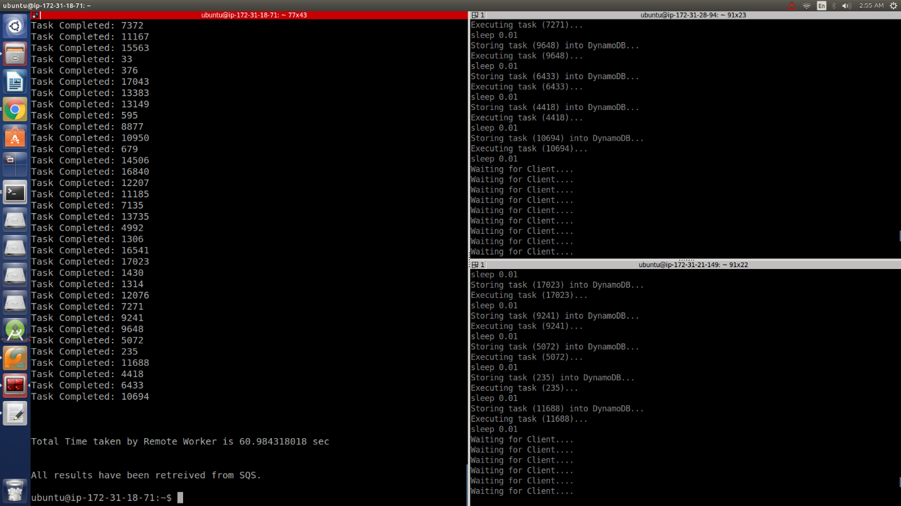

* 2 thread-1 sec:

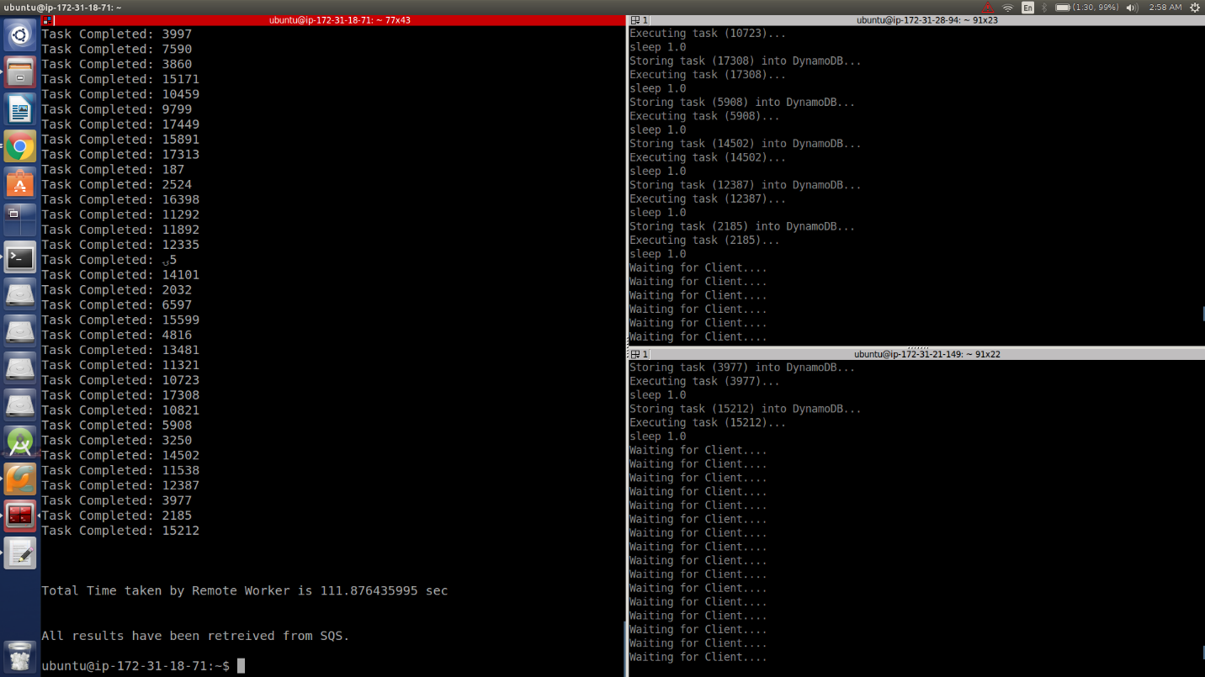

* 2 thread-10 sec:

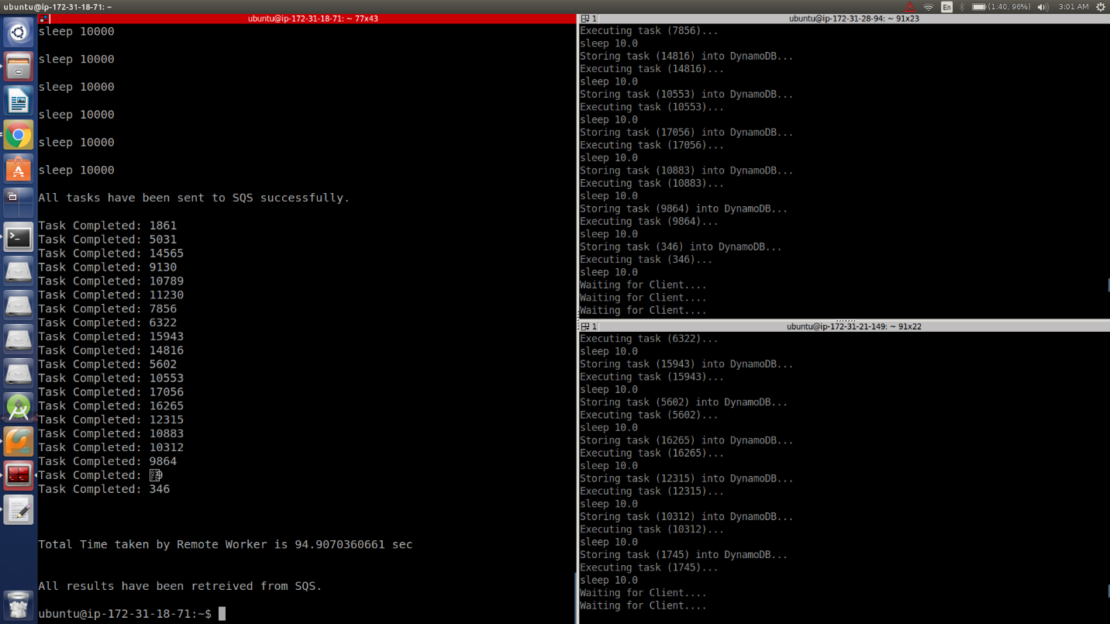

* 4 thread-10 ms:

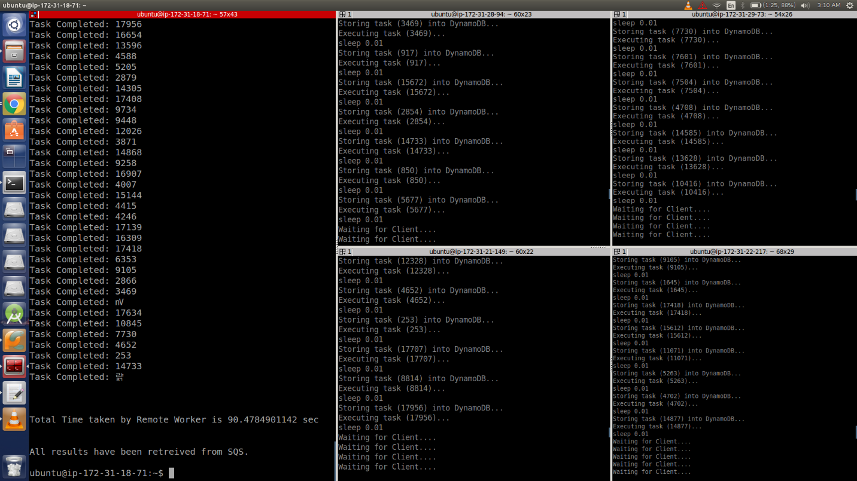

* 4 thread-1 sec:

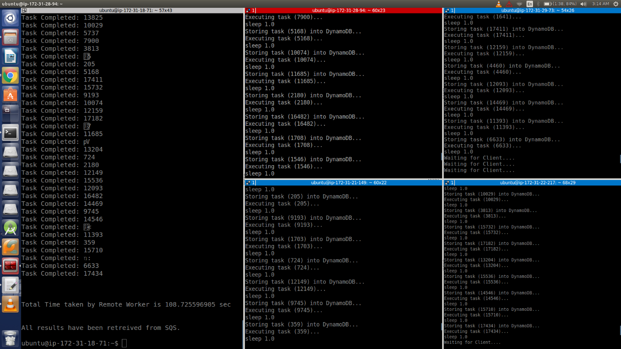

* 4 thread-10 sec:

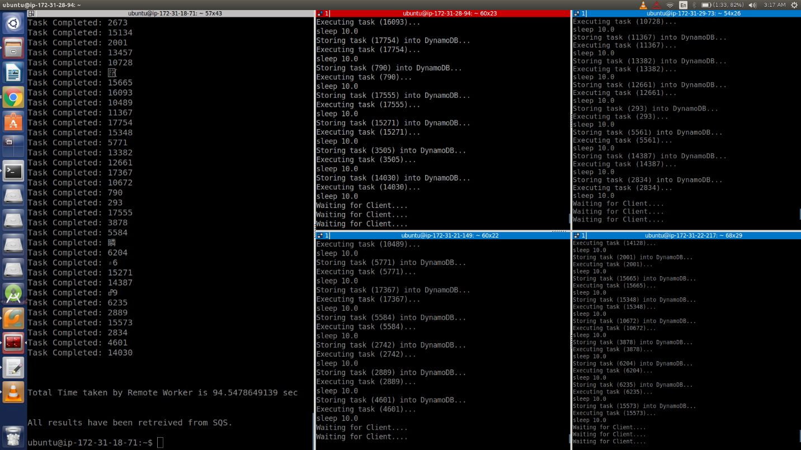

* 8 thread-10 ms:

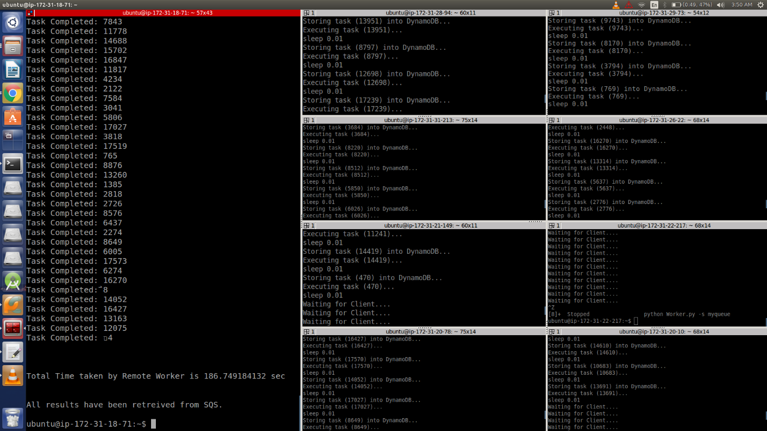

* 8 thread-1 sec:

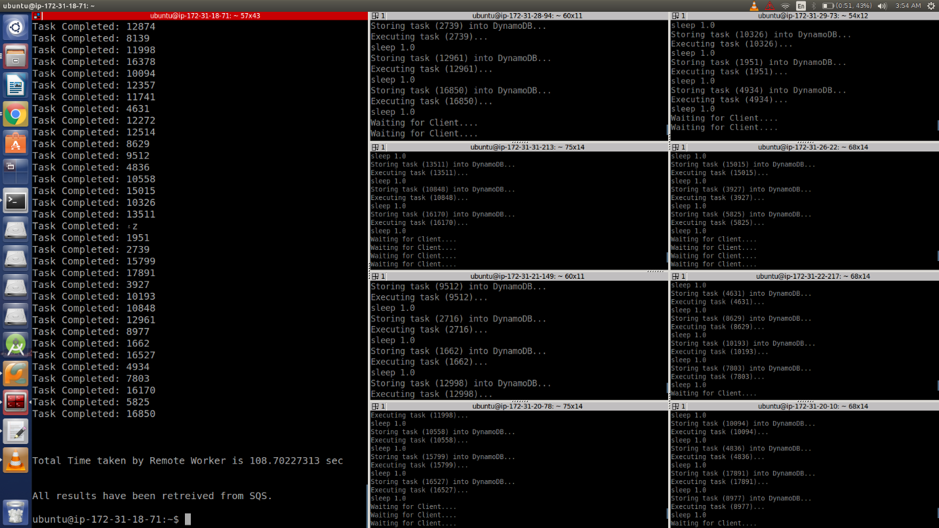

* 8 thread-10 sec:

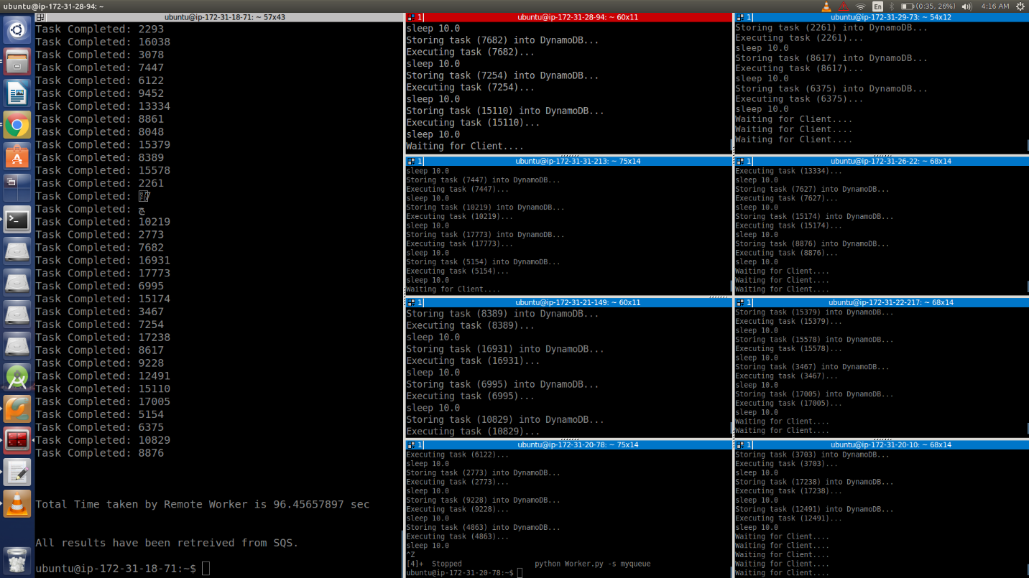

* 16 thread-10 ms:

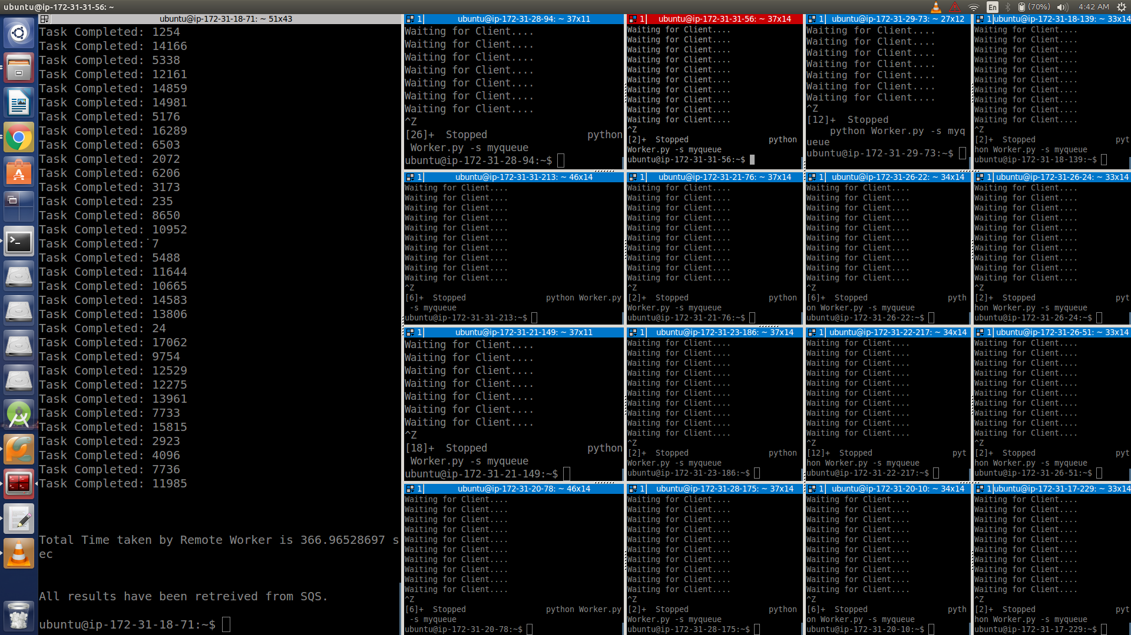

* 16 thread-1 sec:

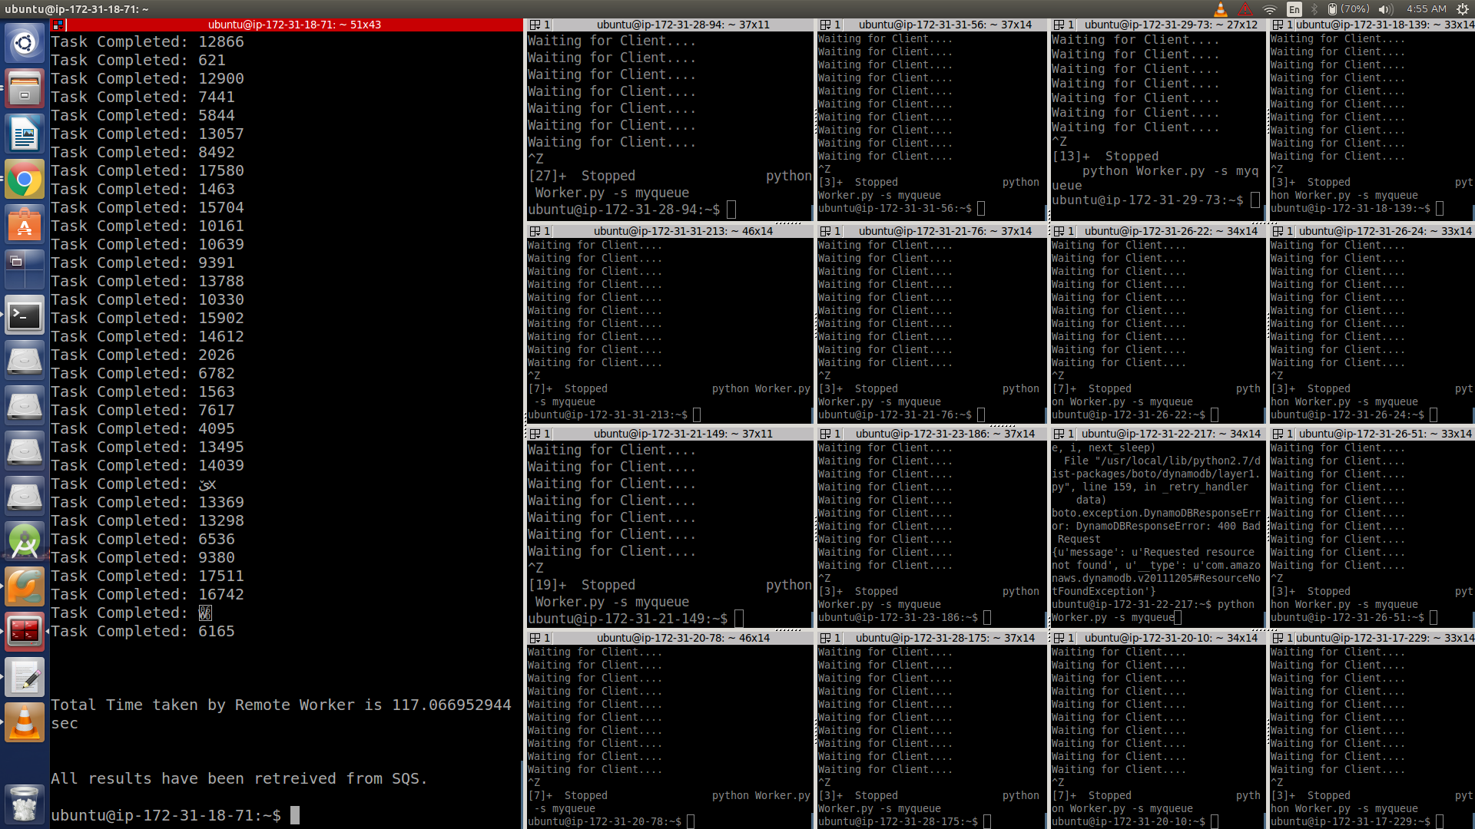

* 16 thread-10 sec:

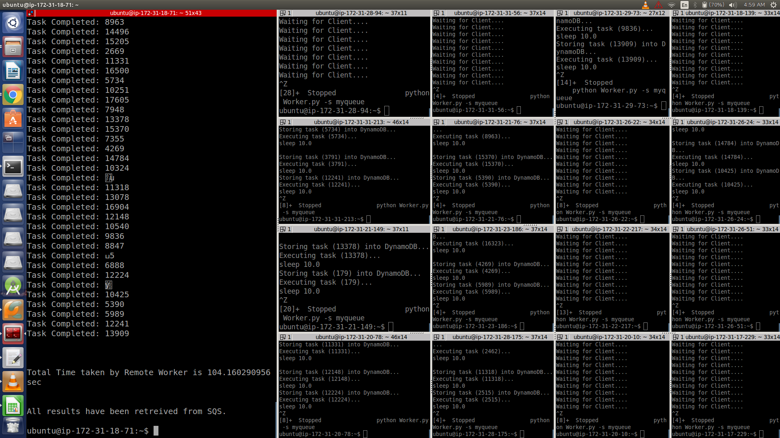

* All workers:

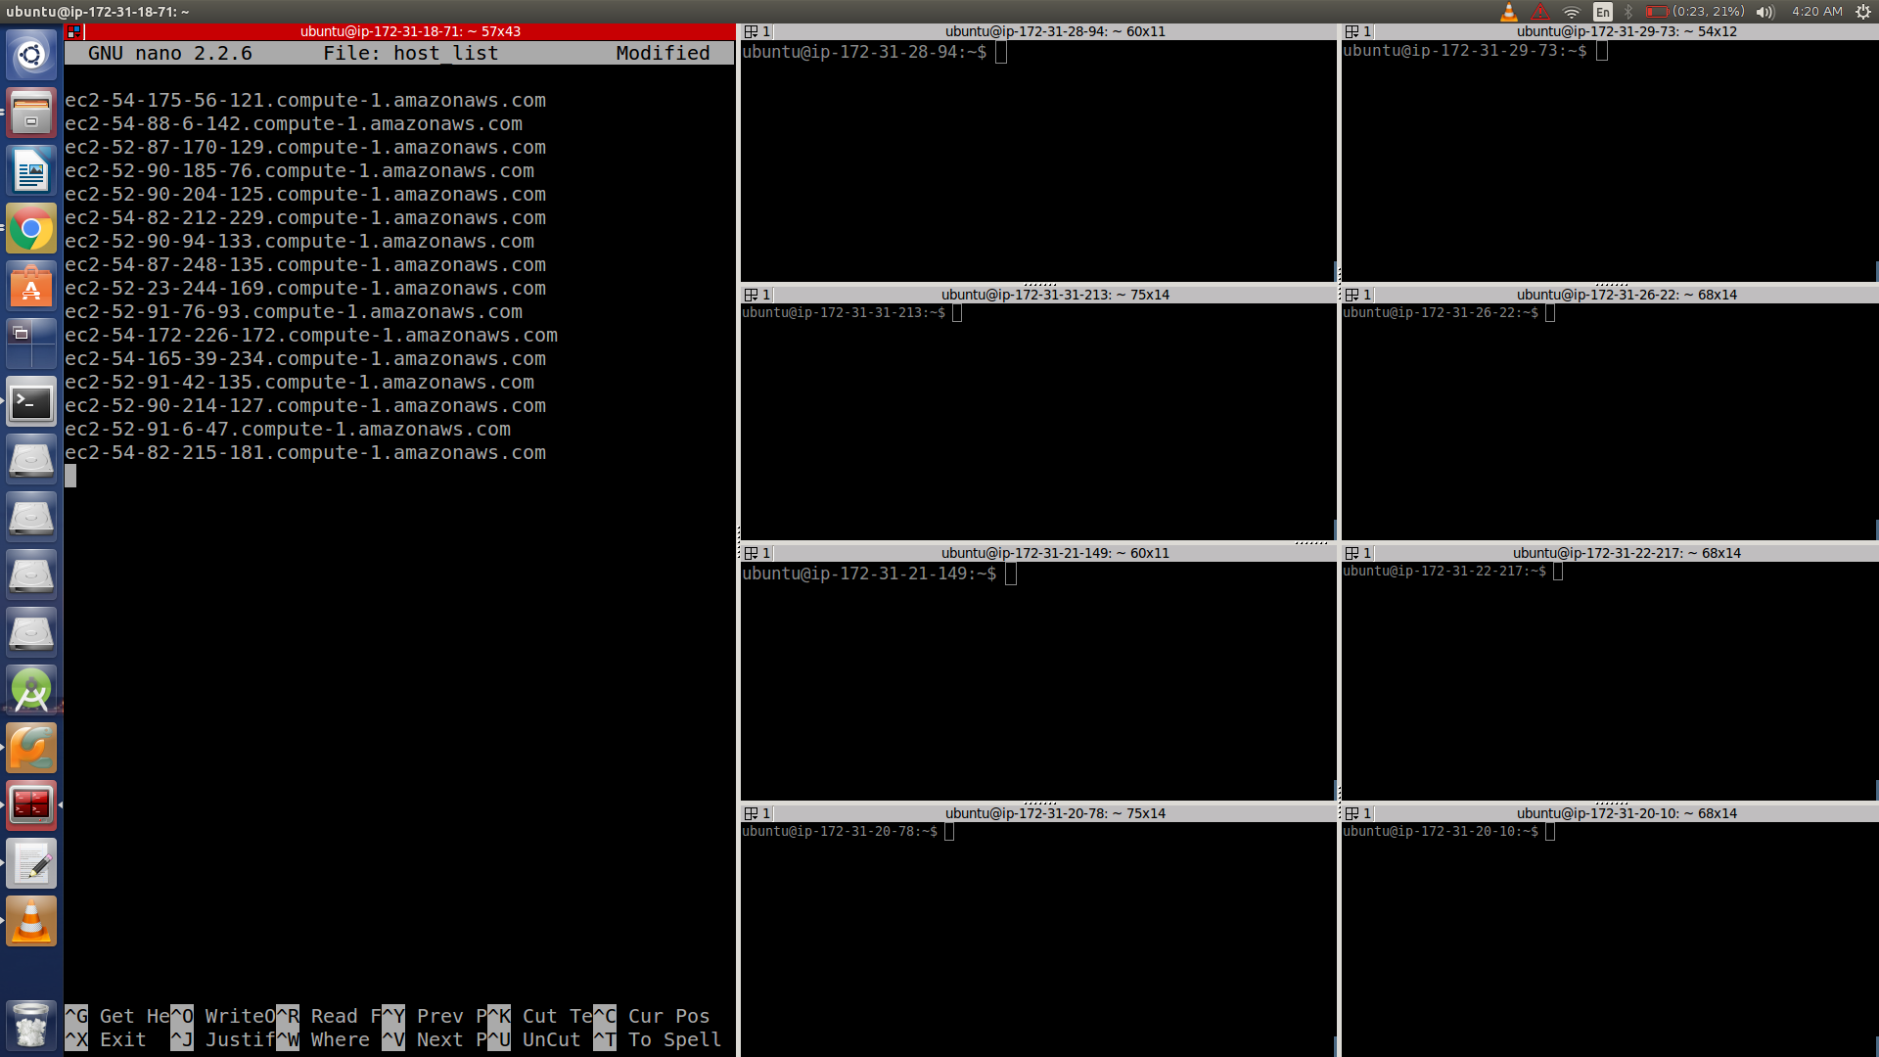

1. Throughput:
   * + 1 Thread (Sleep-0):

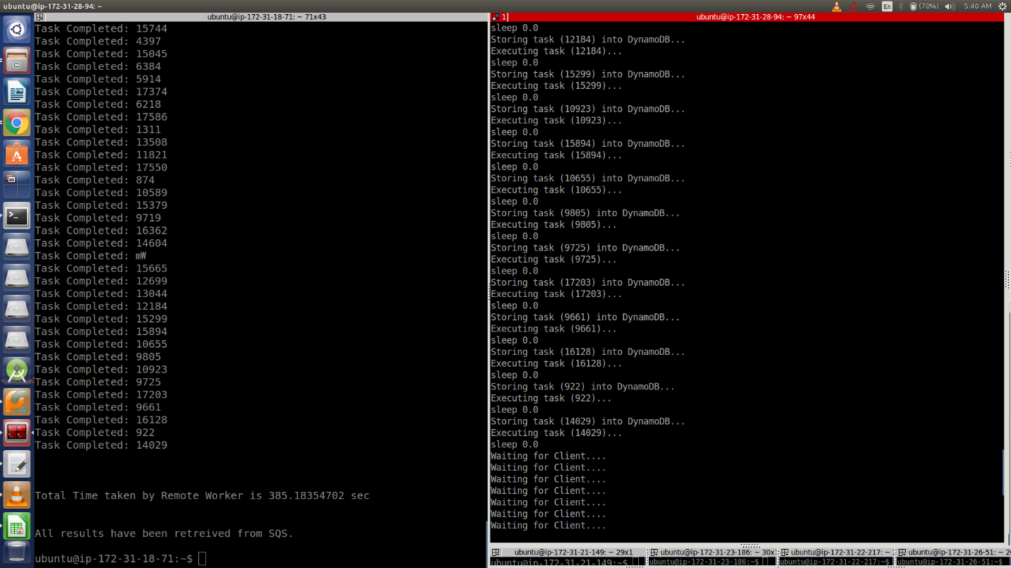

* + - 2 Thread (Sleep-0):

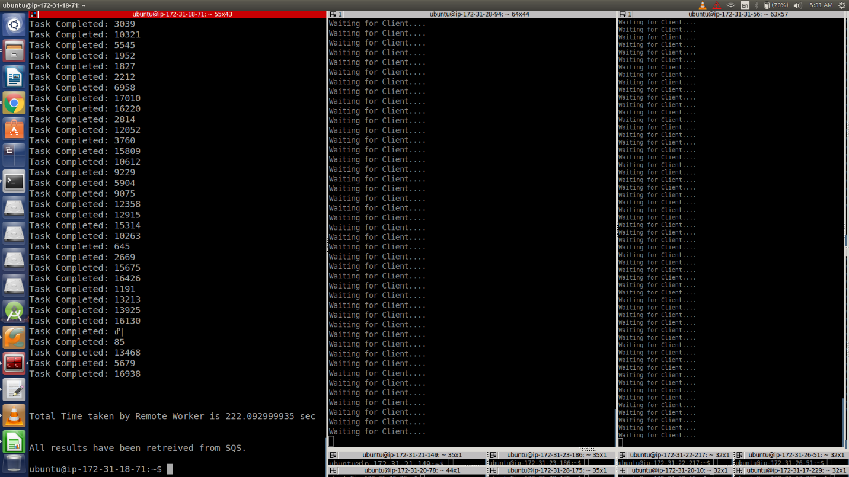

* + - 4 Thread (Sleep-0):

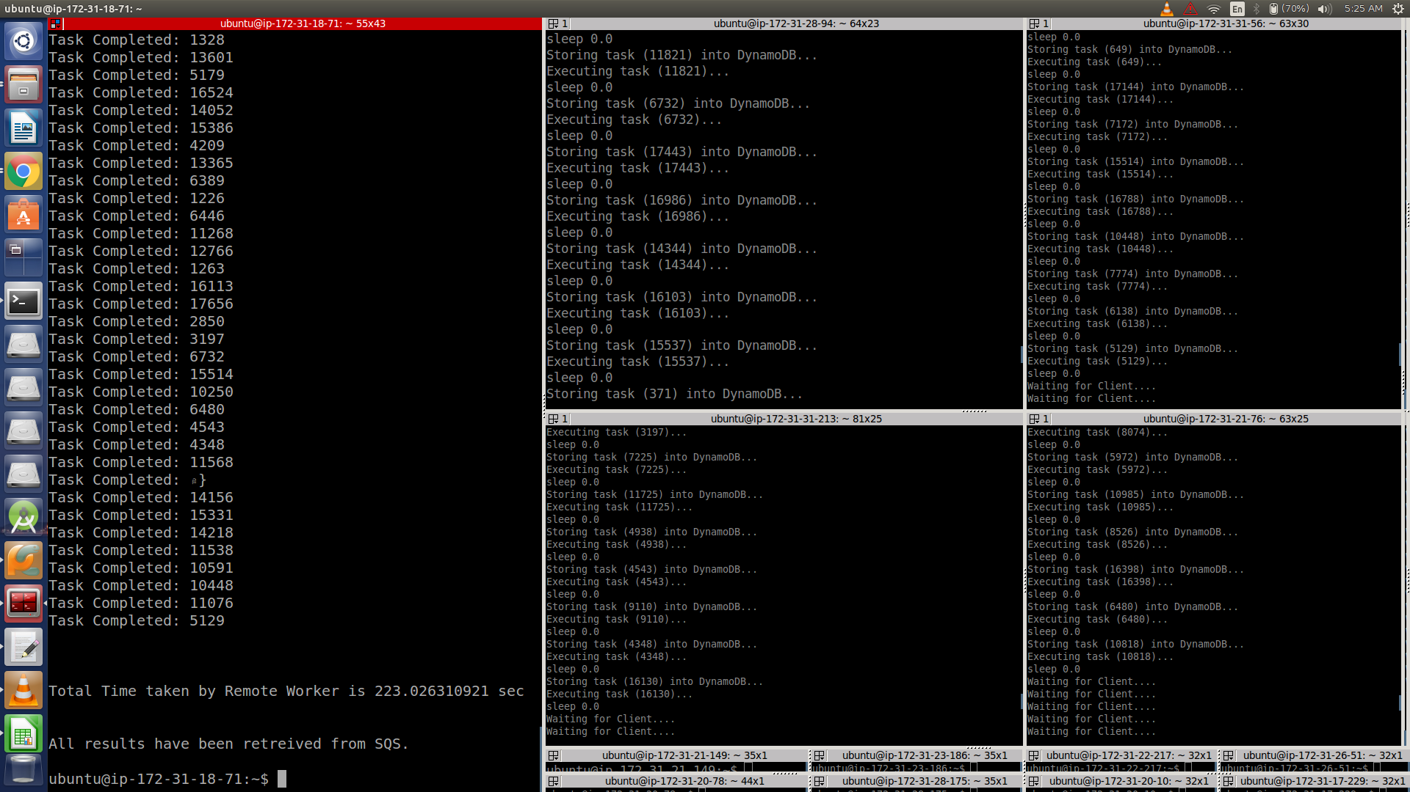

* + - 8 Thread (Sleep-0):

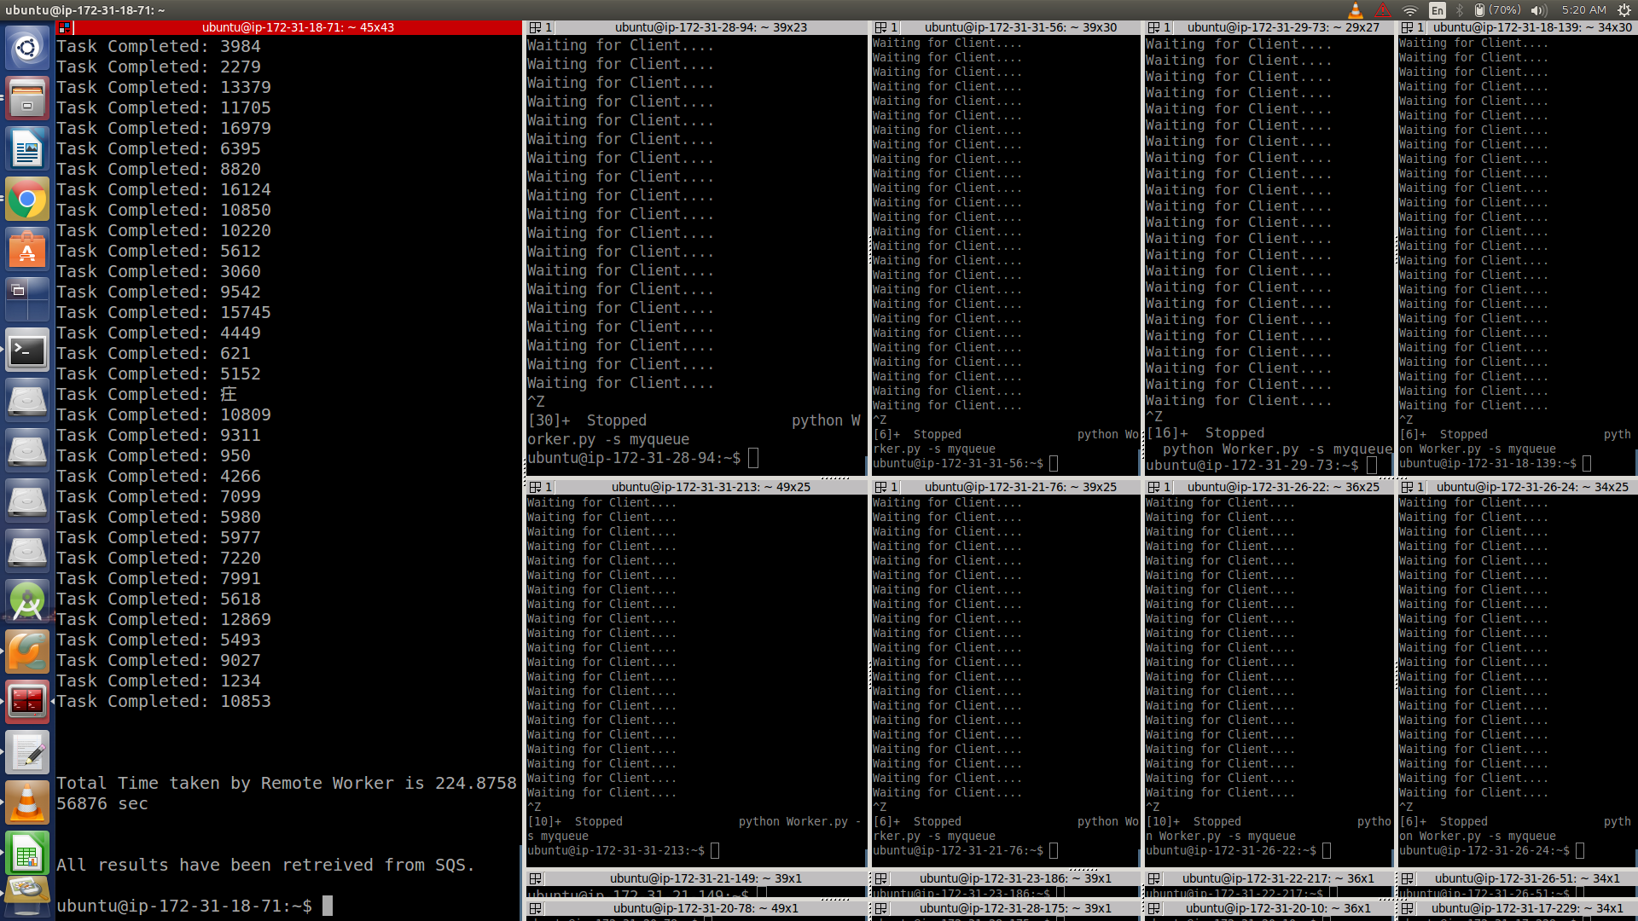

* + - 16 Thread (Sleep-0):

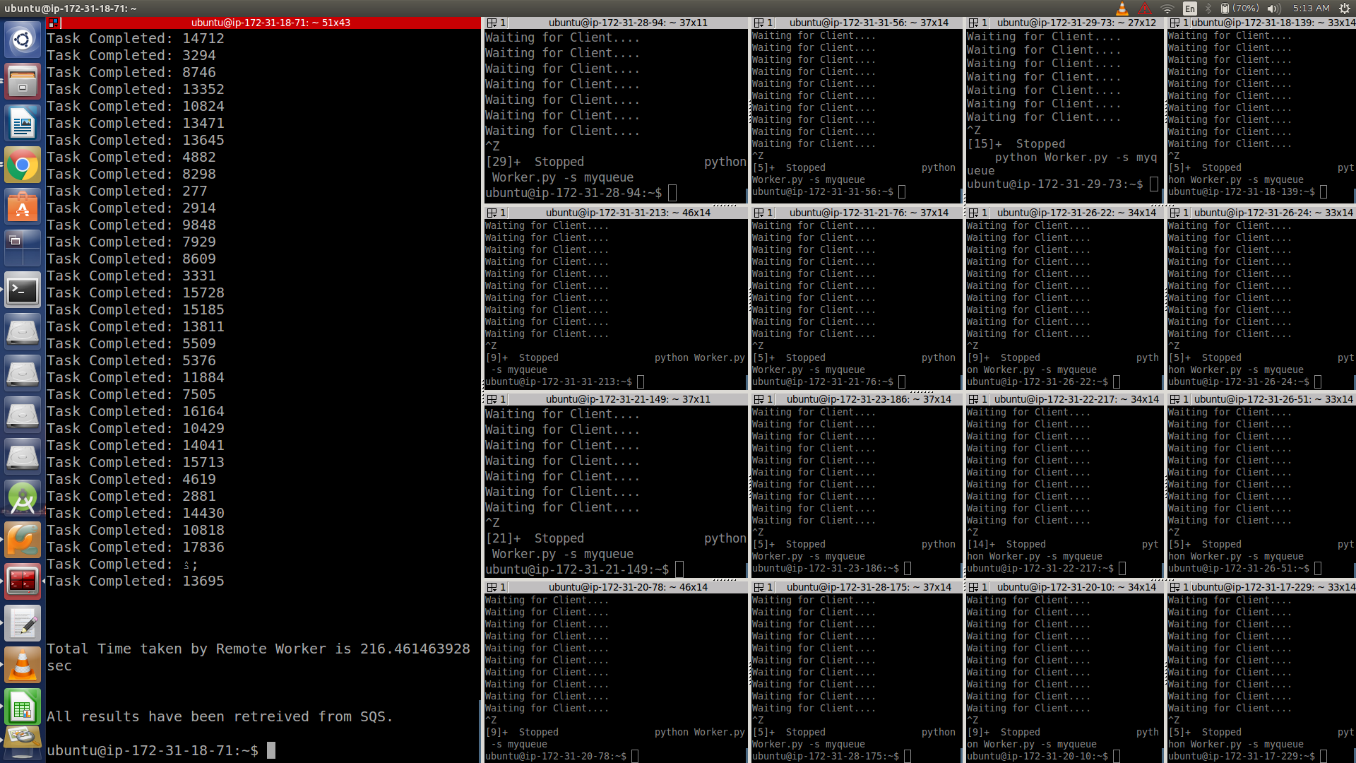

**16 Instances running:**

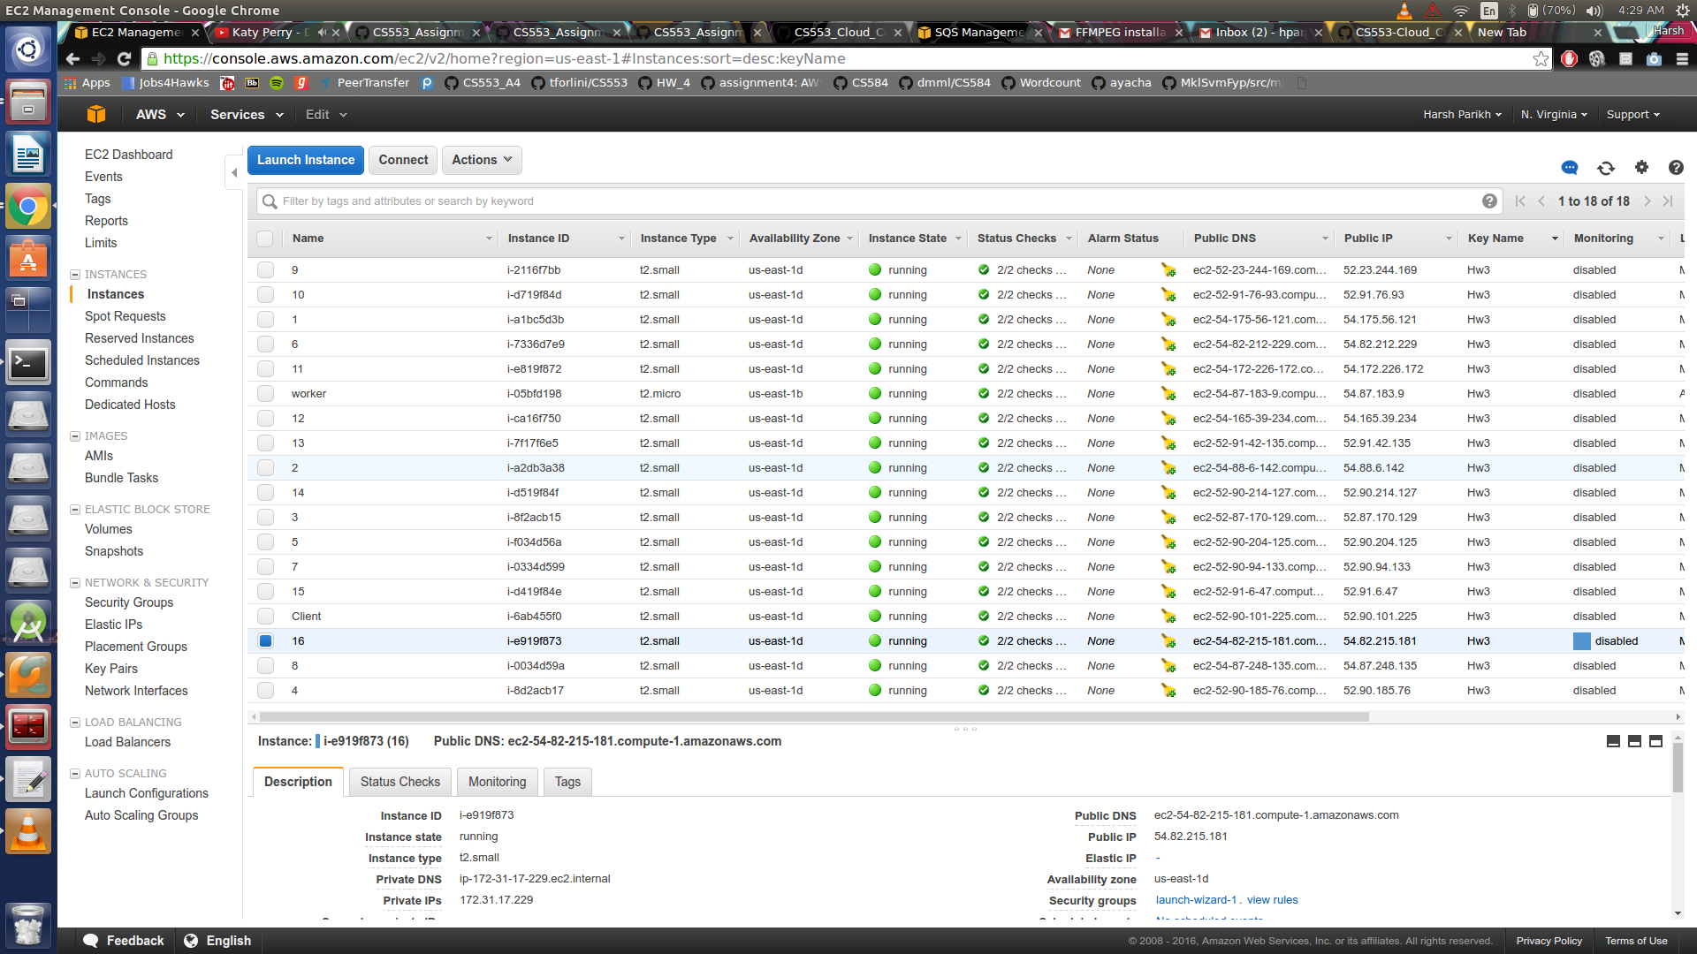

**SQS Working:**

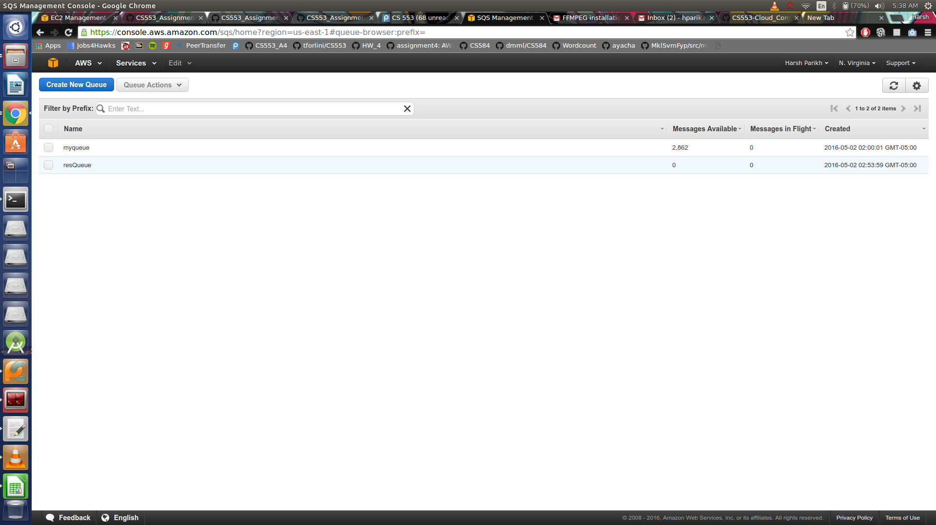

**Animoto Workload/Image file:**

